

OBSERVATIONS OF MAYA AI

WEB APPLICATION

BUG:01
STEP 1: Enter the URL - https://maya.technicalhub.io
STEP 2: Click on Technical Hub Logo.
STEP 3: Verified that while clicking on TechnicalHub Logo, the page is refreshing and getting maya Home page.
Actual Result: Verified that while clicking on TechnicalHub Logo, the page is refreshing and getting maya Home page.
Expected Result: Verify that Link should be removed on TechnicalHub Logo.
￼
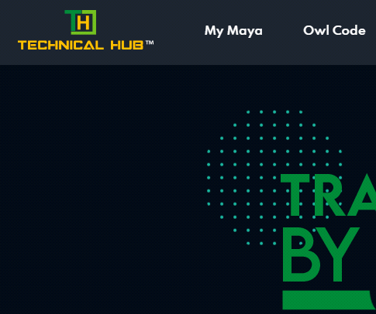
BUG:02
STEP 1: Enter the URL - https://maya.technicalhub.io
STEP 2: Click on ‘My Maya’.
STEP 3: Verified that while clicking on ‘My Maya’, page is refreshing and getting Login page.
Actual Result: Verified that while clicking on ‘My Maya’, page is refreshing and getting Login page.
Expected Result: Verify that Link should be removed on ‘My Maya’.
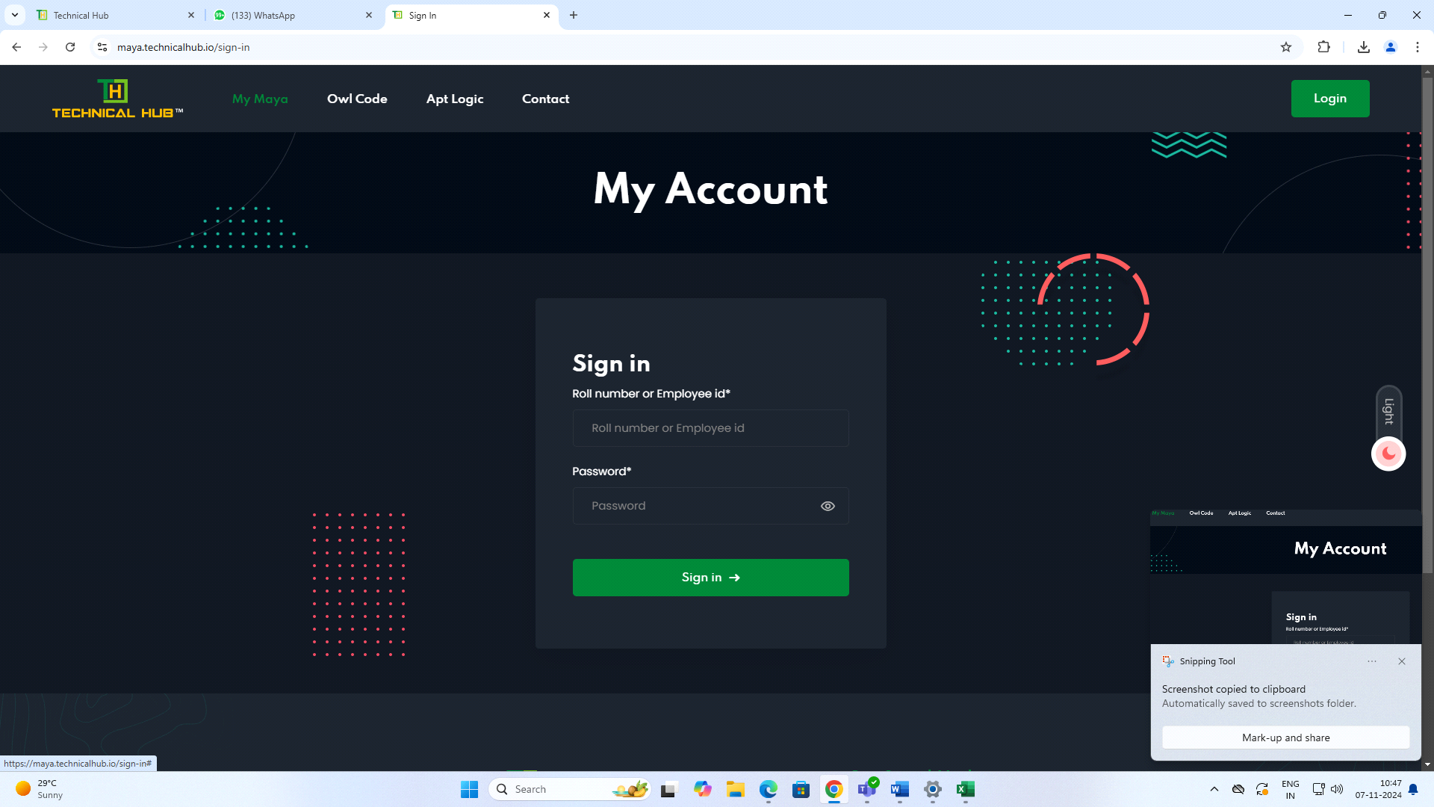
BUG:03
STEP 1: Enter the URL - https://maya.technicalhub.io
STEP 2: Click on 'Owl Code '.
STEP 3: Verified that while clicking on 'Owl Code', page is refreshing and getting Login page.
Actual Result: Verified that while clicking on 'Owl Code ', page is refreshing and getting Login page.
Expected Result: Verify that Link should be removed on 'Owl Code '.
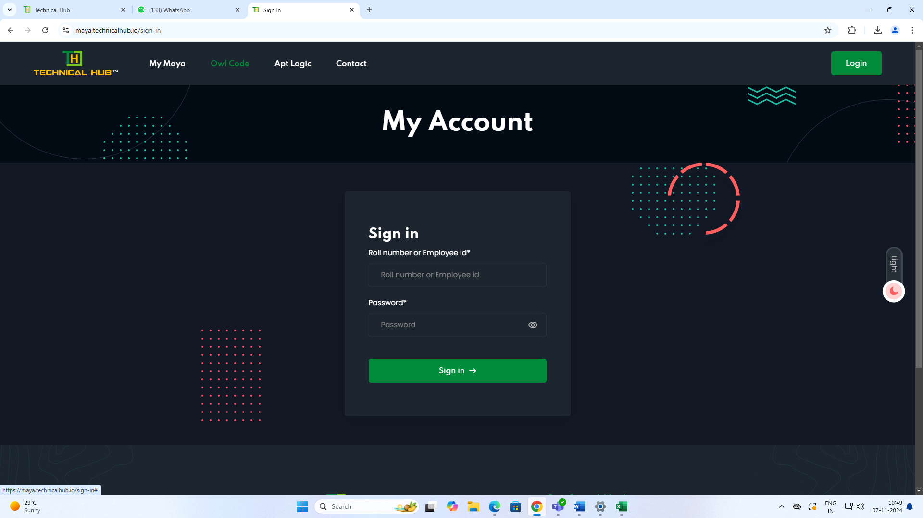
BUG:04
STEP 1: Enter the URL - https://maya.technicalhub.io
STEP 2: Click on 'APT Logic'.
STEP 3: Verified that while clicking on 'APT Logic', page is refreshing and getting Login page.
Actual Result: Verified that while clicking on 'APT Logic', page is refreshing and getting Login page.
Expected Result: Verify that Link should be removed on 'APT Logic'.
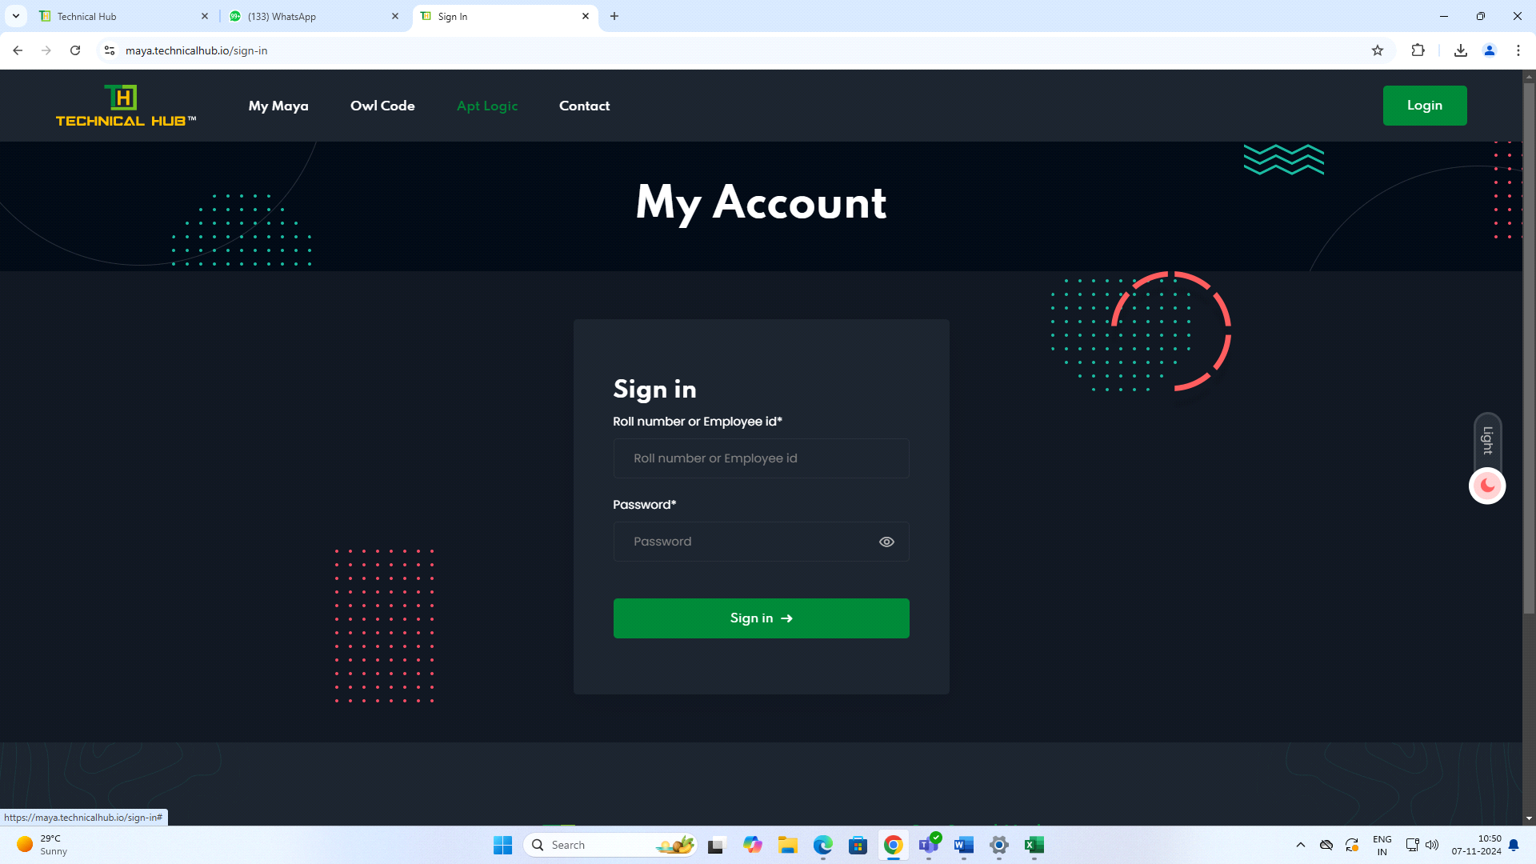
BUG:05
STEP 1: Enter the URL - https://maya.technicalhub.io
STEP 2: Click on 'Contact'.
STEP 3: Verified that while clicking on Contact, getting Contact details.
STEP 4: Verified that by clicking on 'Twitter Logo', Displaying Twitter login page.
Actual Result: Verified that by while clicking on 'Twitter Logo', Displaying Twitter Login page but there is mismatch in the twitter Logo as per latest changes in Twitter.
Expected Result: Verify that by clicking on 'Twitter Logo' is displaying as a bird, but as per latest changes in twitter is "X".
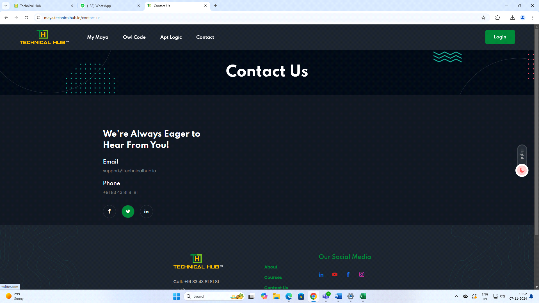
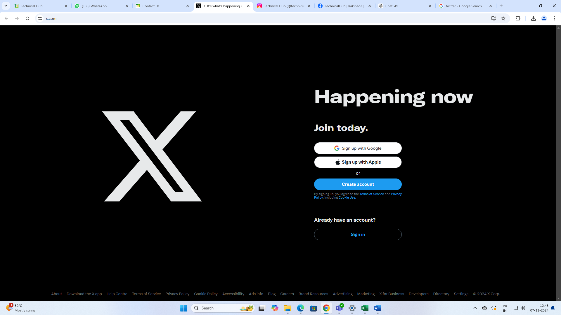
BUG:06
STEP 1: Enter the URL - https://maya.technicalhub.io
STEP 2: Scroll down by clicking mouse.
STEP 3: Find the Technology Training button, Click on Technology Training button.
Actual Result: Verified that while clicking on Technology training button it not redirecting to Course style 1 page, it is redirecting only while clicking on 'Technology training Text'.
Expected Result: Verify that while clicking on Technology training button it should be redirect into Technology Training Courses.
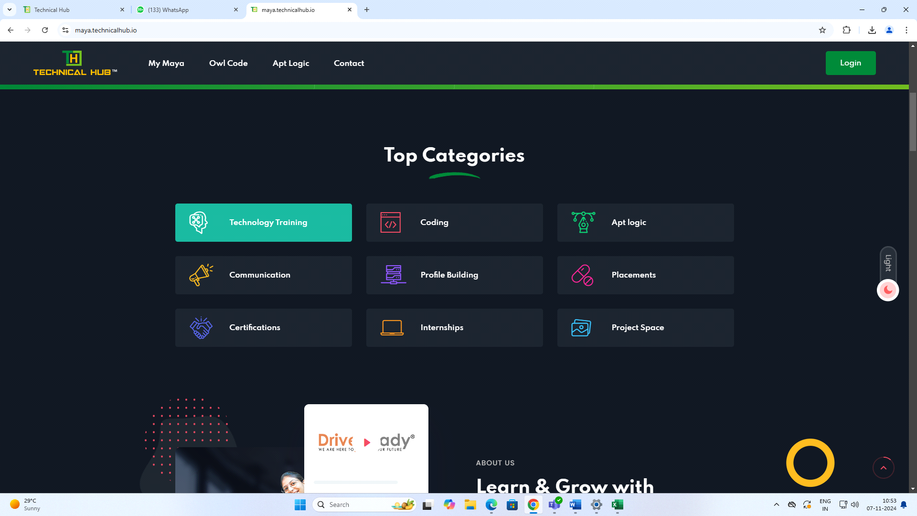
BUG: 07
STEP 1: Enter the URL - https://maya.technicalhub.io
STEP 2: Scroll down by clicking mouse.
STEP 3: Find the Coding button, Click on Coding button.
Actual Result: Verified that while clicking on Coding button it not redirecting to Course style 1 page, it is redirecting only while clicking on 'Coding Text'.
Expected Result: Verify that while clicking on Coding button it should be redirect into Coding Courses.
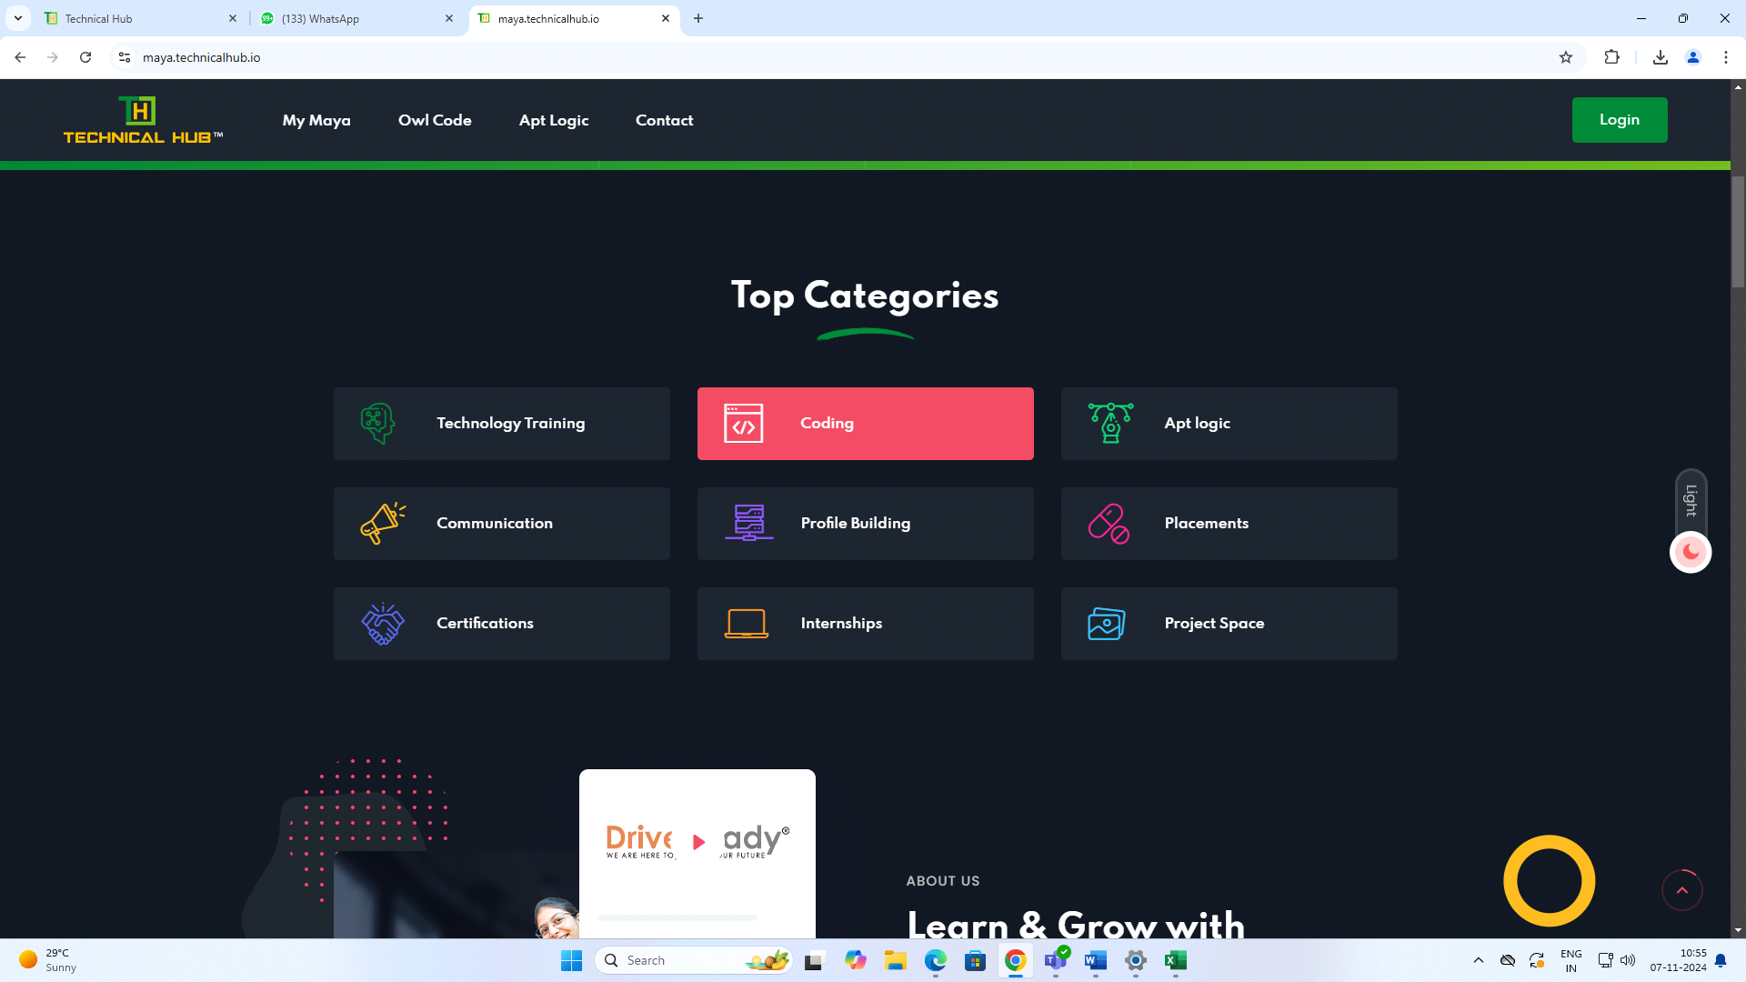BUG:08
STEP 1: Enter the URL - https://maya.technicalhub.io
STEP 2: Scroll down by clicking mouse.
STEP 3: Find the Apt Logic button, Click on APT Logic button.
Actual Result: Verified that while clicking on APT Logic button it not redirecting to Course style 1 page, it’s redirecting only while clicking on 'APT Logic Text'.
Expected Result: Verified that while clicking on APT Logic button it should be redirect into APT Logic Courses.
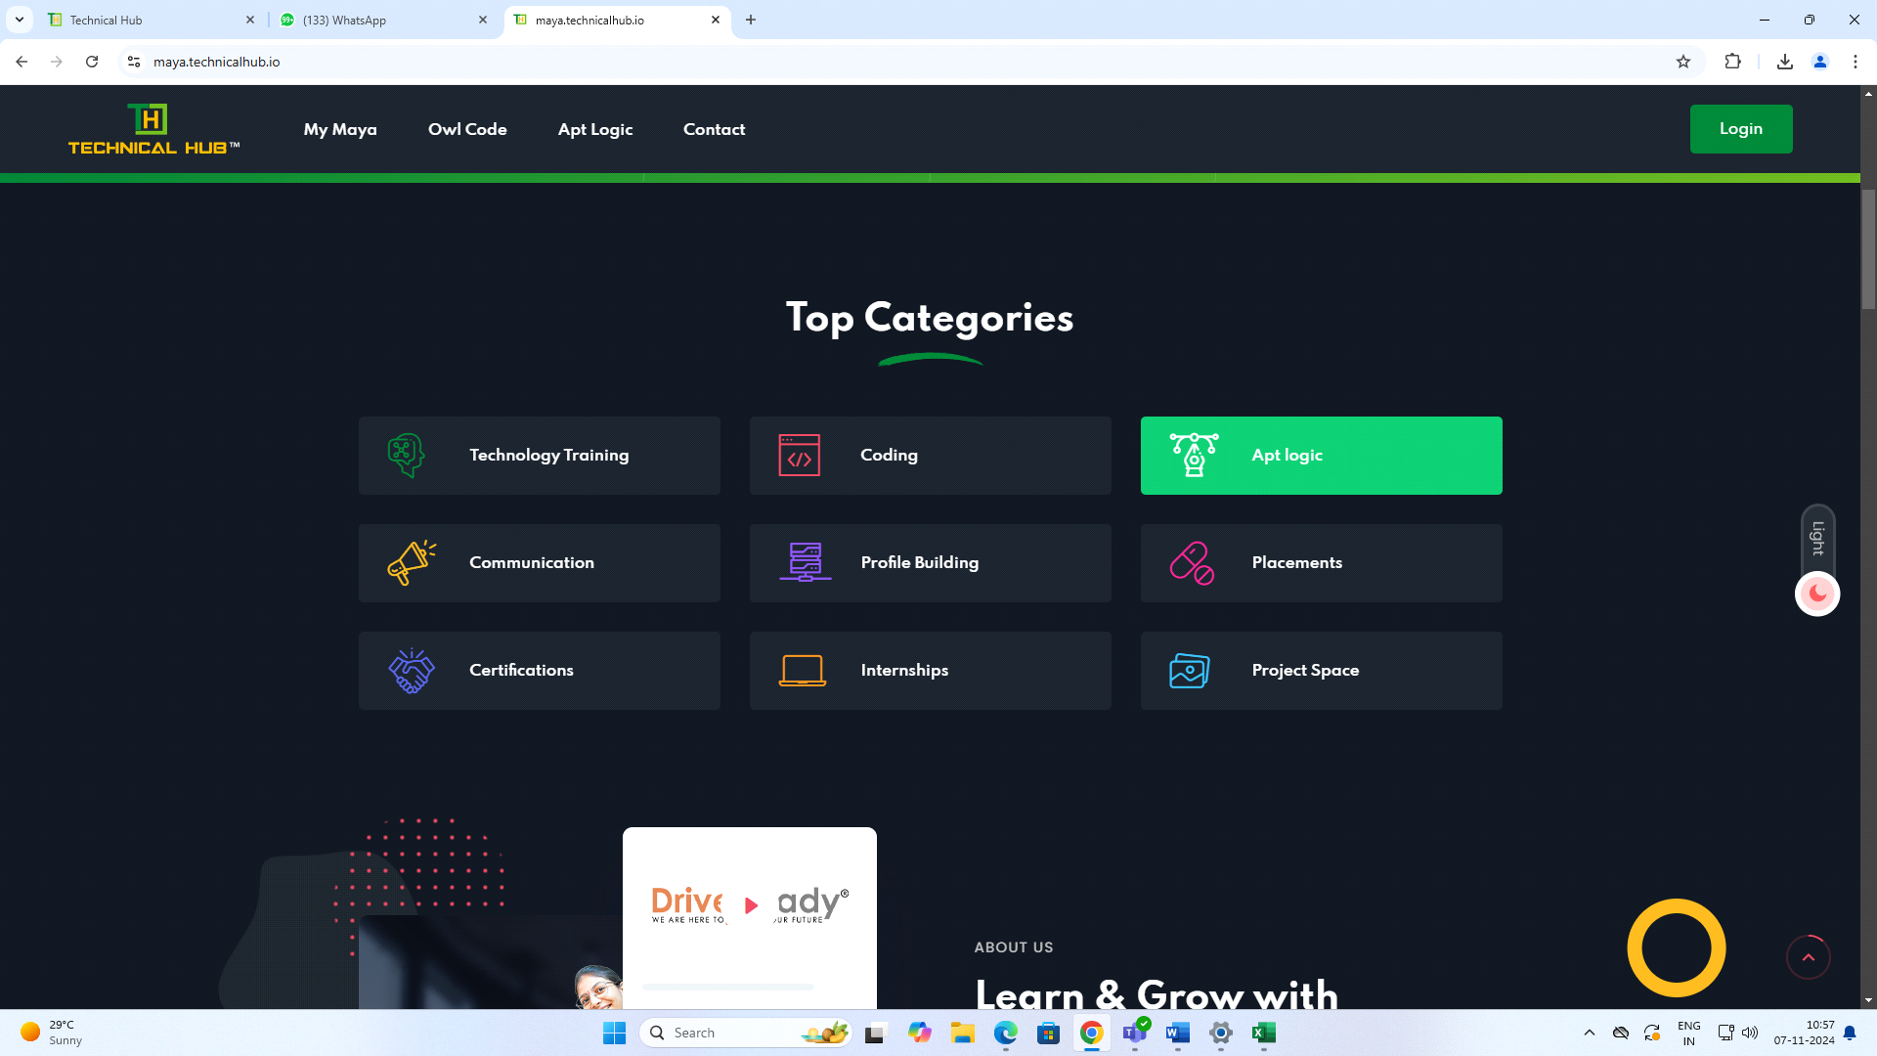BUG: 09
STEP 1: Enter the URL - https://maya.technicalhub.io
STEP 2: Scroll down by clicking mouse.
STEP 3: Find the Communication button, Click on Communication button.
Actual Result: Verified that while clicking on Communication button it not redirecting to Course style 1 page, its redirecting only while clicking on Communication "Text".
Expected Result: Verify that while clicking on Communication button it should be redirect into Communication Courses.
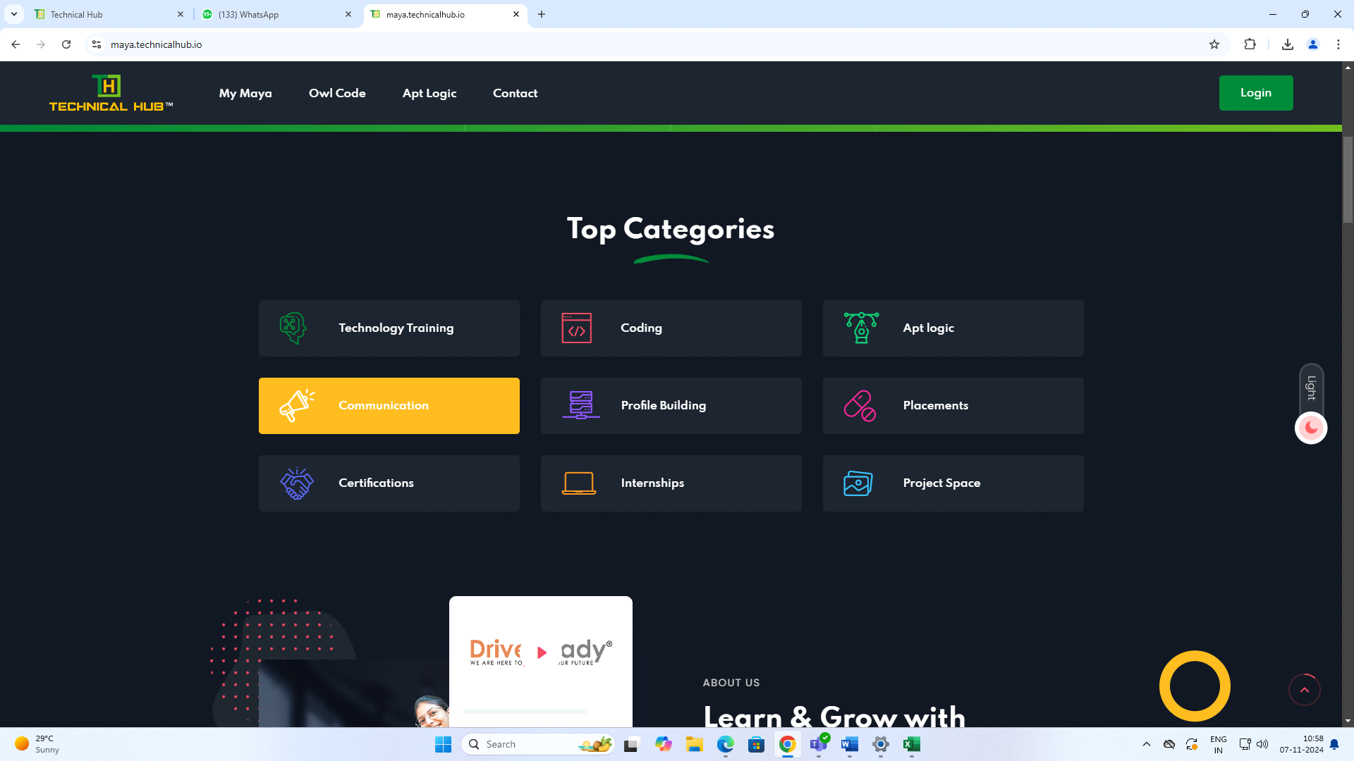
BUG: 10
STEP 1: Enter the URL - https://maya.technicalhub.io
STEP 2: Scroll down by clicking mouse.
STEP 3: Find the Profile Building button, Click on Profile Building button.
Actual Result: Verified that while clicking on Profile Building button it not redirecting to Course style 1 page, it is redirecting only while clicking on 'Profile Building Text'.
Expected Result: Verify that while clicking on Profile Building button it should be redirect into Profile Building Courses.
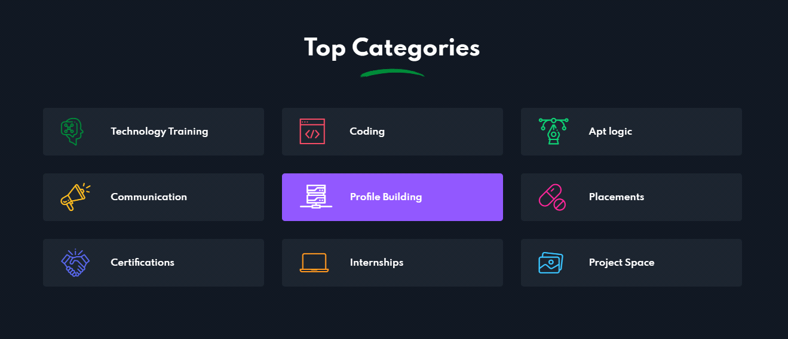
BUG: 11
STEP 1: Enter the URL - https://maya.technicalhub.io
STEP 2: Scroll down by clicking mouse.
STEP 3: Find the Profile Placements button, Click on Placements button.
Actual Result: Verified that while clicking on Placements button it not redirecting to Course style 1 page, it is redirecting only while clicking on 'Placements Text'.
Expected Result: Verify that while clicking on Placements button it should be redirect into Placements Courses.
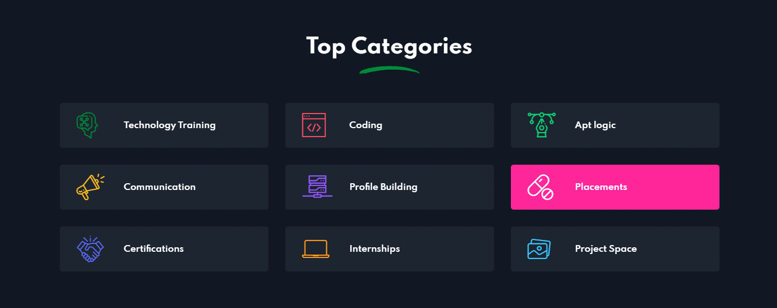
BUG: 12
STEP 1: Enter the URL - https://maya.technicalhub.io
STEP 2: Scroll down by clicking mouse.
STEP 3: Find the Profile Certifications button, Click on Certifications button.
Actual Result: Verified that while clicking on Certifications button it not redirecting to Course style 1 page, its redirecting only while clicking on 'Certifications Text'.
Expected Result: Verify that while clicking on Certifications button it should be redirect into Certifications Courses.
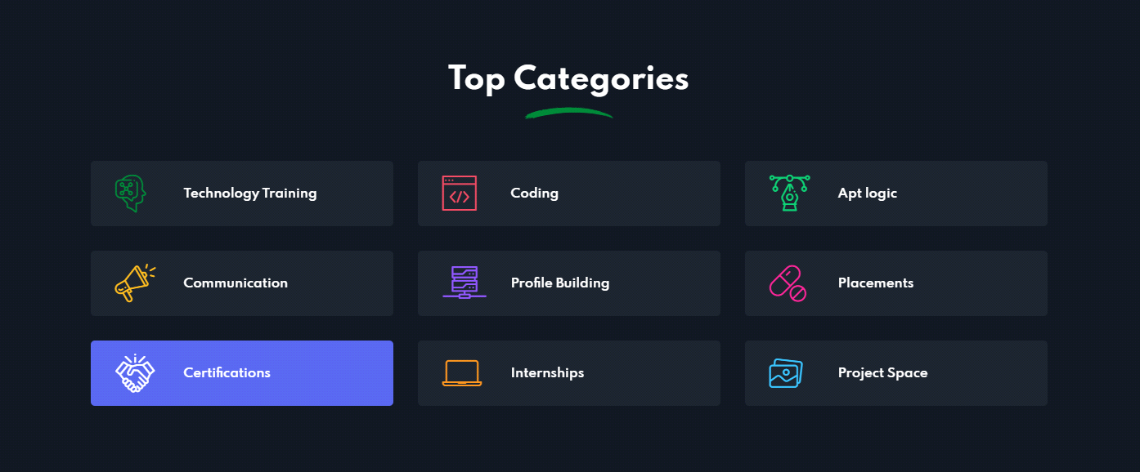
BUG: 13
STEP 1: Enter the URL - https://maya.technicalhub.io
STEP 2: Scroll down by clicking mouse.
STEP 3: Find the Profile Internships button, Click on Internships button.
Actual Result: Verified that while clicking on Internships button it not redirecting to Course style 1 page, it’s redirecting only while clicking on 'Internships Text'.
Expected Result: Verify that while clicking on Internships button it should be redirect into Internships Courses.
\ 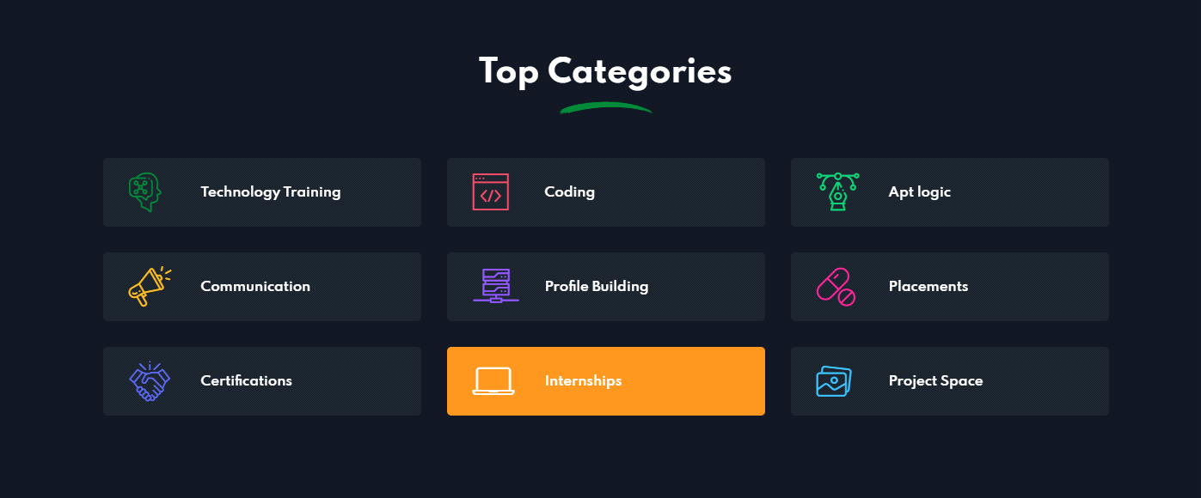
BUG: 14
STEP 1: Enter the URL - https://maya.technicalhub.io
STEP 2: Scroll down by clicking mouse.
STEP 3: Find the Profile Project Space button, Click Project Space button.
Actual Result: Verified that while clicking on Project Space button it not redirecting to Course style 1 page, it’s redirecting only while clicking on 'Project Space Text'.
Expected Result: Verify that while clicking on Project Space button it should be redirect into Project Space Courses.
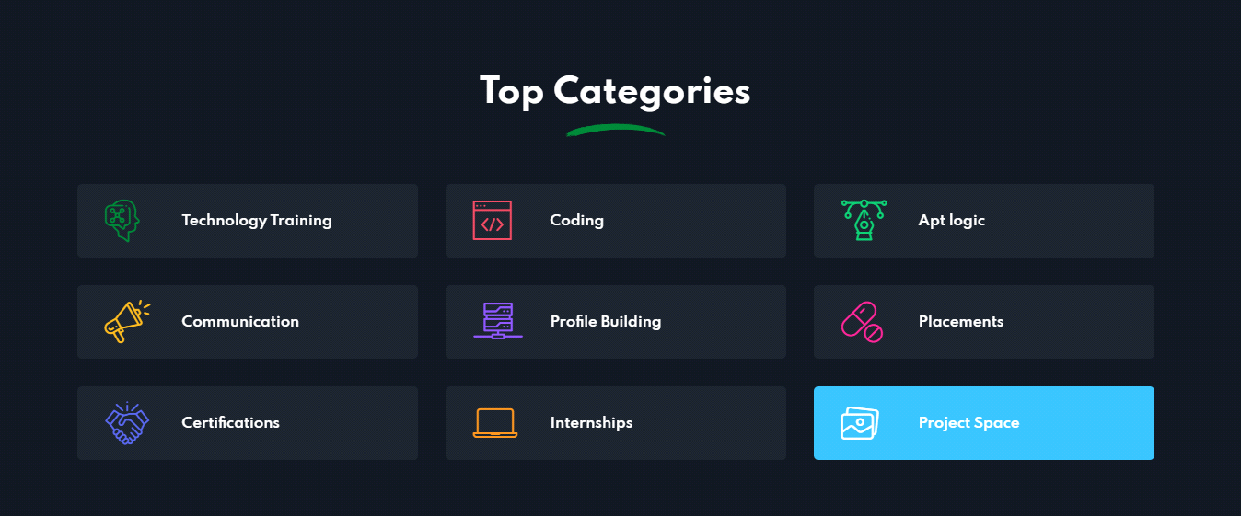 BUG: 15
STEP 1: Enter the URL - https://maya.technicalhub.io
STEP 2: Scroll down by clicking mouse.
STEP 3: Find the 'Get in Touch' button, click on 'Get in Touch' button.
Actual Result: Verified that while clicking on 'Get in Touch' button it going to back to top of the same page.
Expected Result: Verify that while clicking on 'Get in Touch' button it should redirect to the mail apps.

BUG :16
STEP 1: Enter the URL - https://maya.technicalhub.io
STEP 2: Scroll down by clicking mouse.
STEP 3: Click on browse more courses button.
Actual result: Verified that while clicking on browse more courses button it displays the courses. while we go for to top categories in that Technologies Training same courses is displayed.
Expected Result: Verify that all the courses are all in one place.
This is placed in 2 places in top categories and pick a course
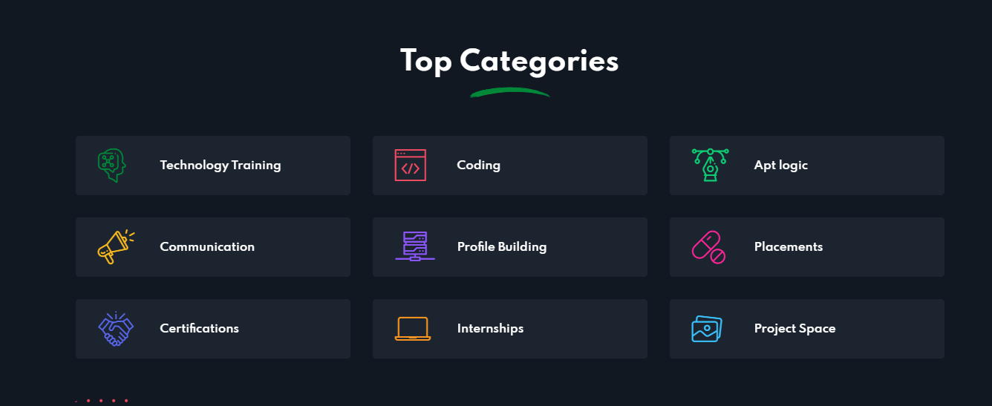
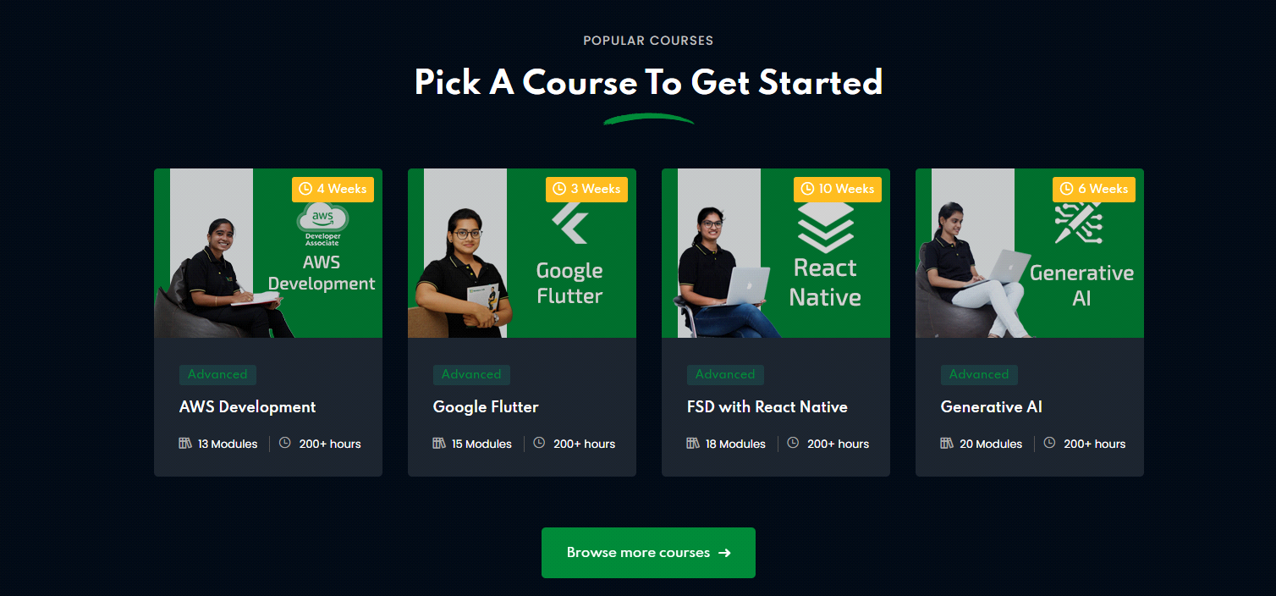BUG :17
STEP 1: Enter the URL - https://maya.technicalhub.io
STEP 2: Scroll down by clicking mouse.
STEP 3: Find the ‘Latest Articles’, Check the latest Articles.
Actual Result: Verified that while clicking on that latest Articles it shows the reviews but not displaying the images. It shows the Pictures pixel sizes only.
Expected Result: Verify that while checking on Latest Articles it should be display the images.
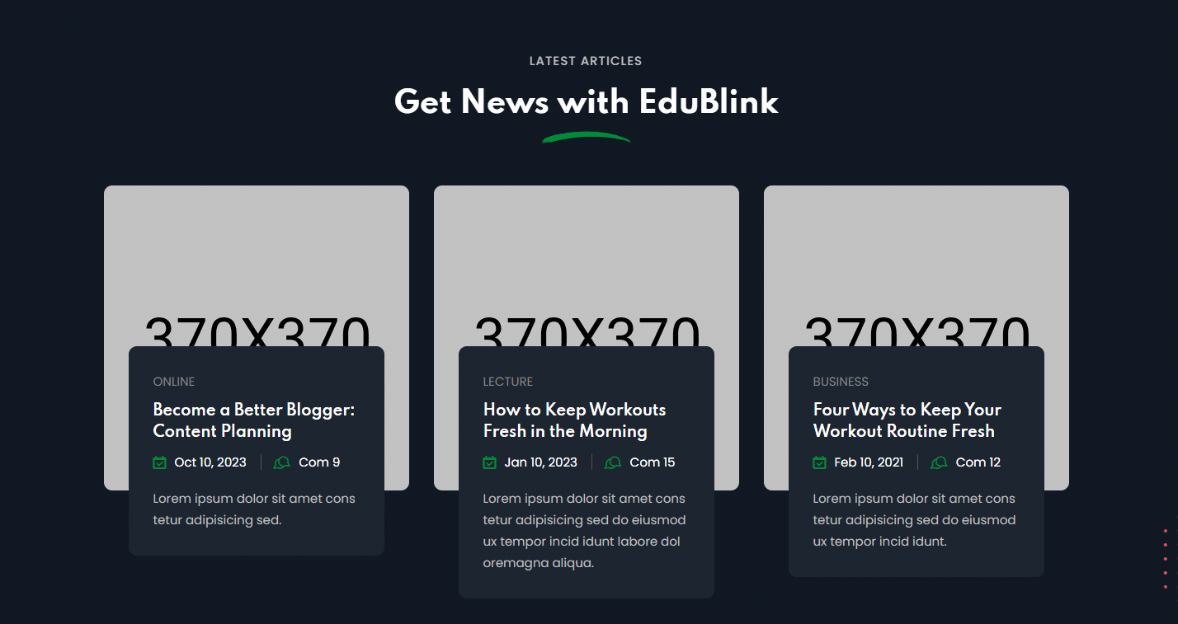

BUG :18
STEP 1: Enter the URL - https://maya.technicalhub.io
STEP 2: Scroll down by clicking mouse.
STEP 3: Find the Technicalhub Logo, click on that Logo.
Actual Result: Verified that while clicking on the logo it is going top of the page.
Expected Result: Verify that while clicking on it does not act as link. It looks only the Text format.


BUG :19
STEP 1: Enter the URL - https://maya.technicalhub.io
STEP 2: Scroll down by clicking mouse.
STEP 3: Find the Instagram Logo, click on that Logo.
Actual Result: Verified that while clicking on the logo it is open the Instagram app. It is working in one system but parallel it opens in another system it’s not working.
Expected Result: Verify while Instagram should be open in all devices.
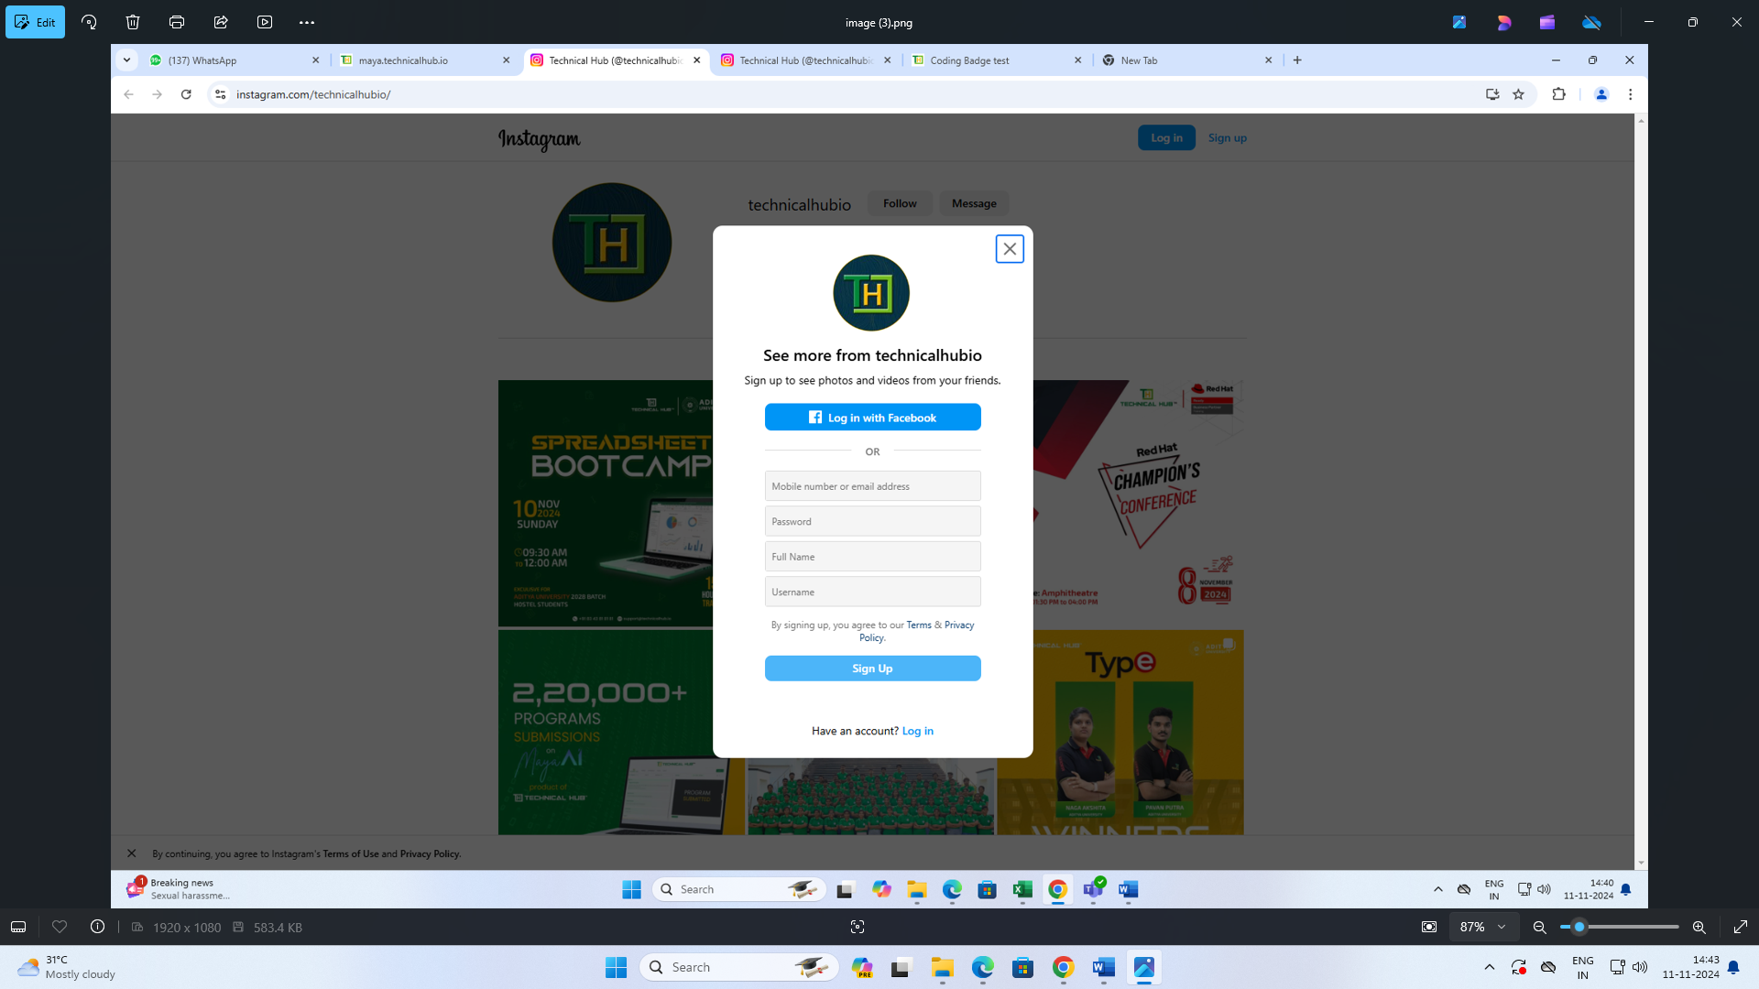

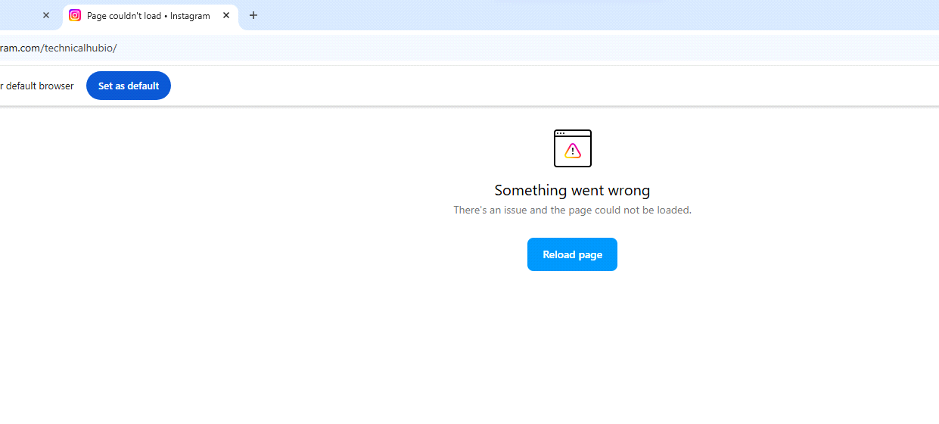

BUG:20
STEP 1: Enter the URL - https://maya.technicalhub.io
STEP 2: Click on ‘Login’ Button’.
STEP 3: Verified that while clicking on ‘Login’ button by giving invalid credentials.
Roll no: 200000001, Password: Thub@1234
Actual Result: Verified that an error message was displayed at the top corner of the page.
Expected Result: Verify that an error message will display at the bottom or top of the credentials.
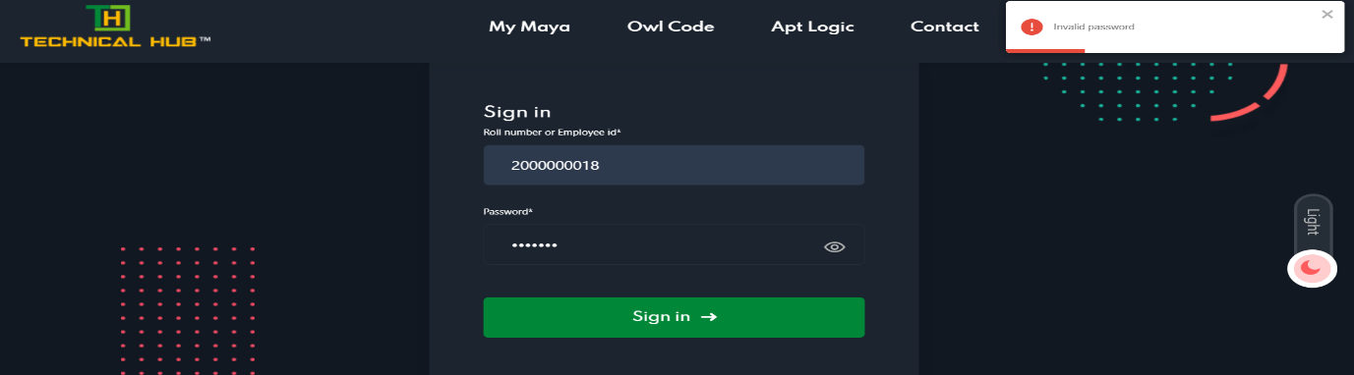

BUG:21
STEP 1: Enter the URL - https://maya.technicalhub.io
STEP 2: Click on ‘Login’ Button.
STEP 3: Verified that while clicking on Login button multiple times by giving invalid credentials.
Roll no: 200000001, Password: Thub@1234
Actual Result: Verified that an error message was displayed at the top corner of the page in multiple times.
Expected Result: Verify that an error message will display single time only when we click multiple times.
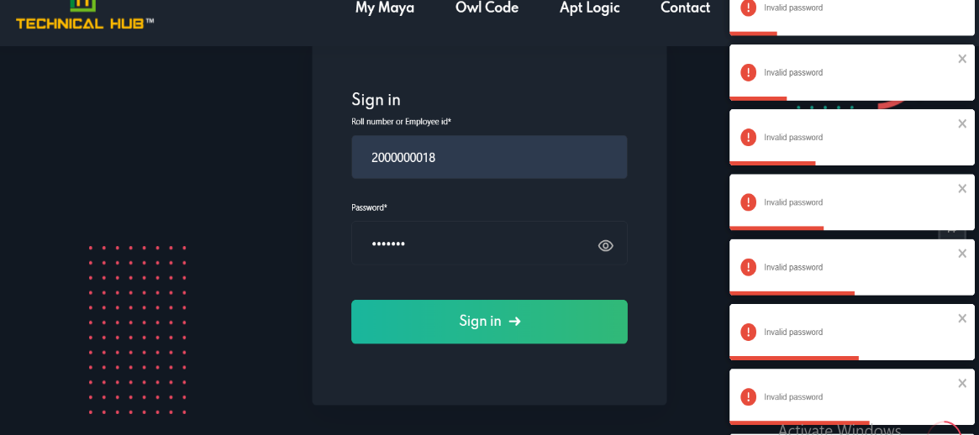
BUG:22
STEP 1: Once user login successfully in My Maya.
STEP 2: Click on Courses, it is navigated to courses Page.
Actual Result: Verified that 24 courses currently show in My maya Page when we navigate to courses page 24 courses are not displayed.
Expected Result: Verify that register courses should be display.
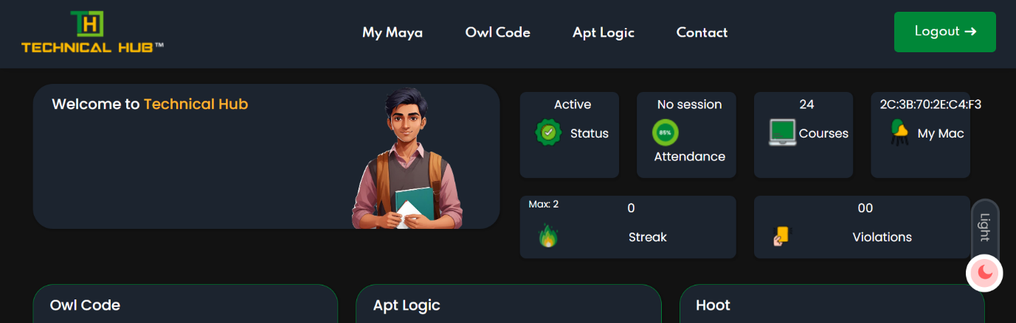

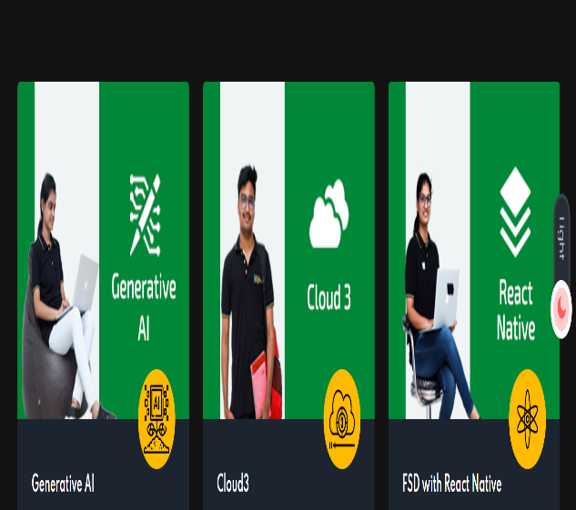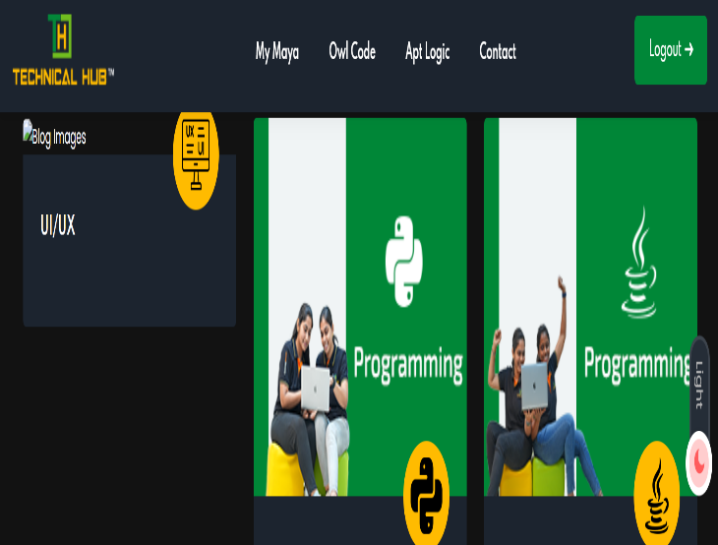

BUG:23
STEP 1: Once user login successfully in My Maya.
STEP 2: Click on ‘Courses’, it is navigated to Courses Page.
Actual Result: Verified that some courses does not have images.
Expected Result: Verify that all courses' images should be display.
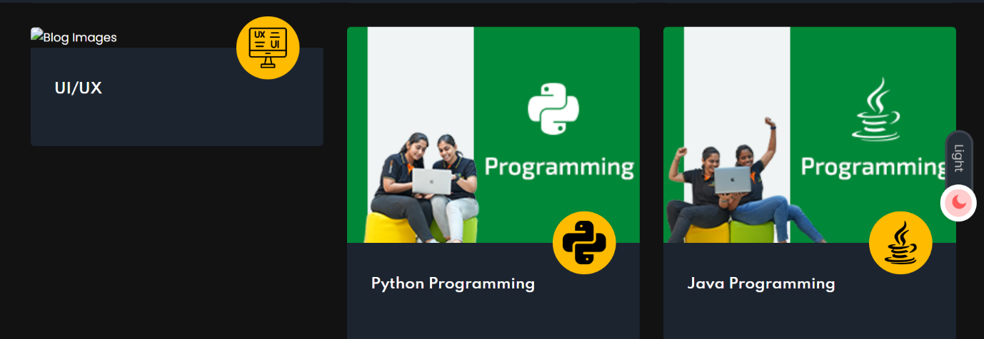BUG:24
STEP 1: Once user login successfully in My Maya.
STEP 2: Click on ‘My Maya’.
STEP 3: Verified that while clicking on light mode to dark mode.
Actual Result: The background colour doesn’t been changed in welcome to technicalhub image.
Expected Result: The background colour must be same in in welcome to technicalhub image for some users.
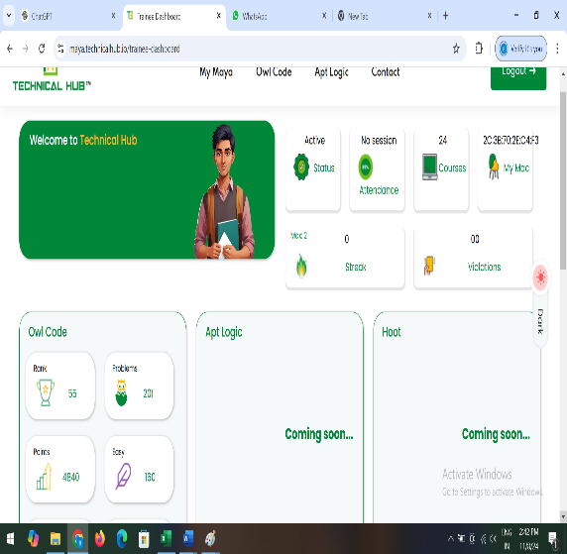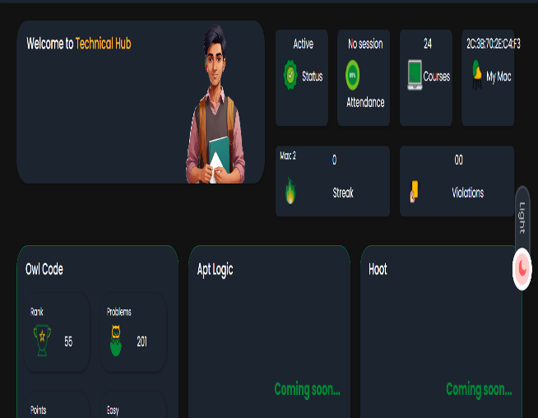

Bug :25
STEP 1: Once user login successfully in My Maya.
STEP 2: Click On ‘Owl Code’.
STEP 3: Verified that while clicking on Owl Code, the page is refreshing and getting Owl dashboard page, while cursor moving on the student profile google lens is activated in edge browser so click on lens, related images are displayed.
Actual Result: Related images are displayed.
Expected Result: Please disable the google lens.
This Issue is facing In Edge Browser
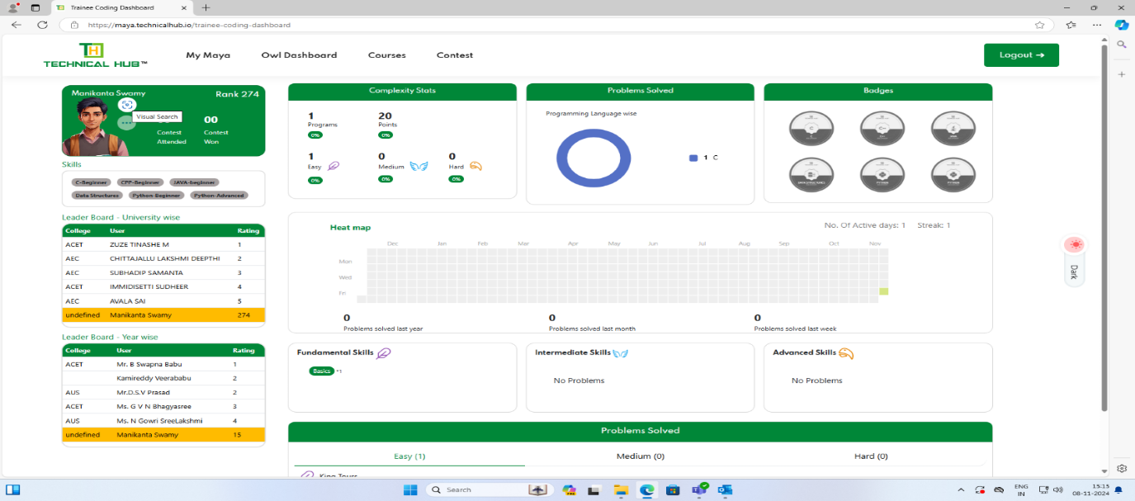
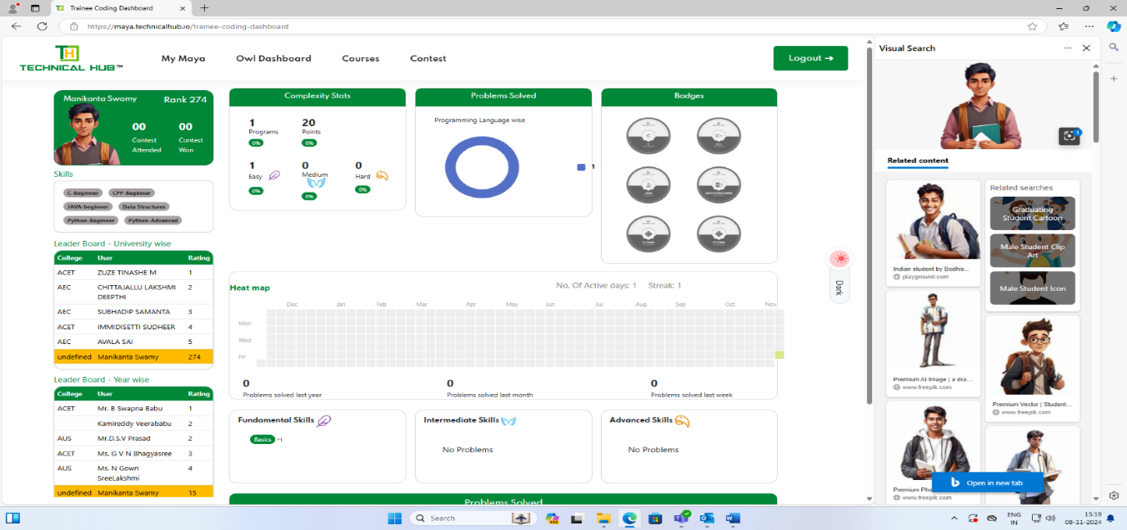

Bug :26
STEP 1: Once user login successfully in My Maya.
STEP 2: Click on ‘Owl Code’.
STEP 3: Click on ‘Dark Mode’, dark mode is activated.
Actual Result: In Dark mode some text is not visible.
Expected Result: In dark mode is on text should be visible.
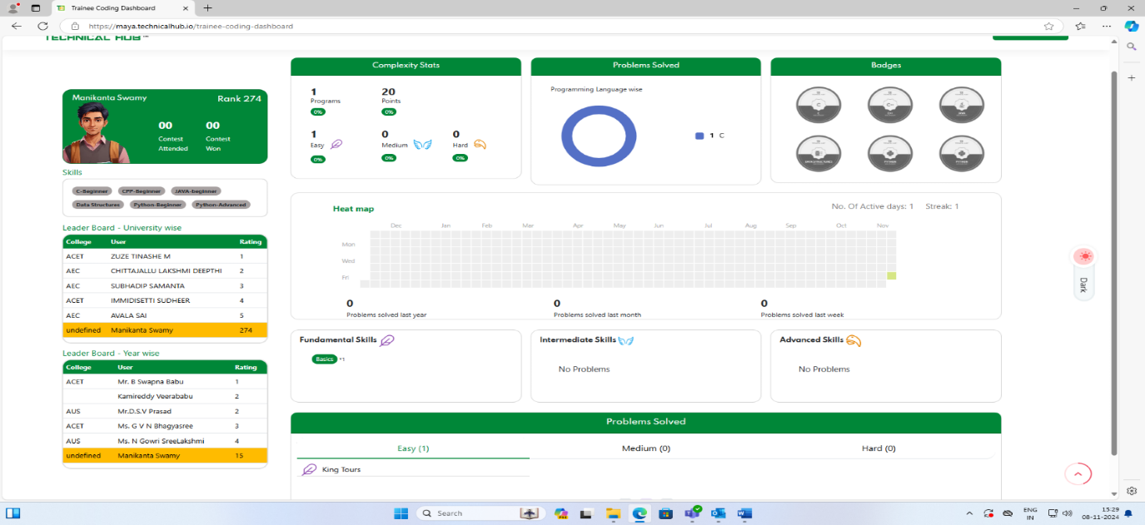
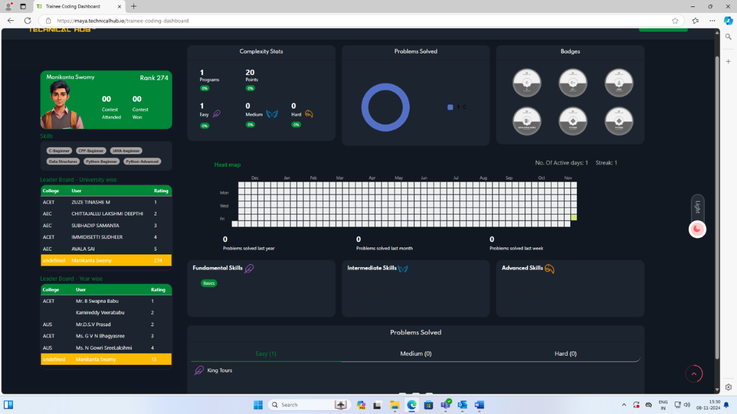

Bug :27
STEP 1: Once user login successfully in My Maya.
STEP 2: Click on ‘Owl Code’.
STEP 3: While clicking on Student image google lens is activated, while click on lens related images are reflecting.
Actual Result: Problems solved text is not adjusted.
Expected Result: Problems solved text adjust boundary.
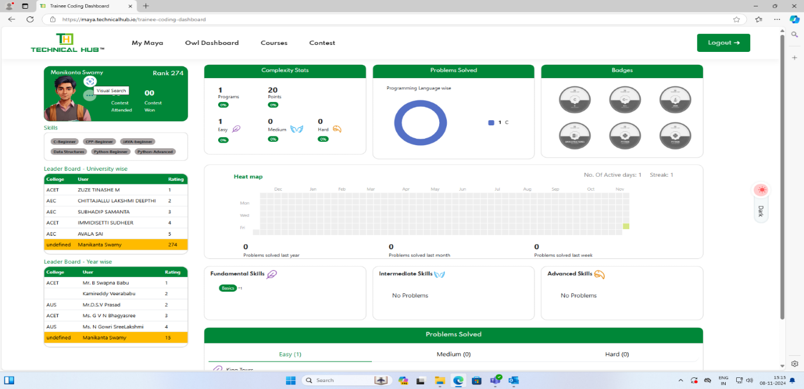
`
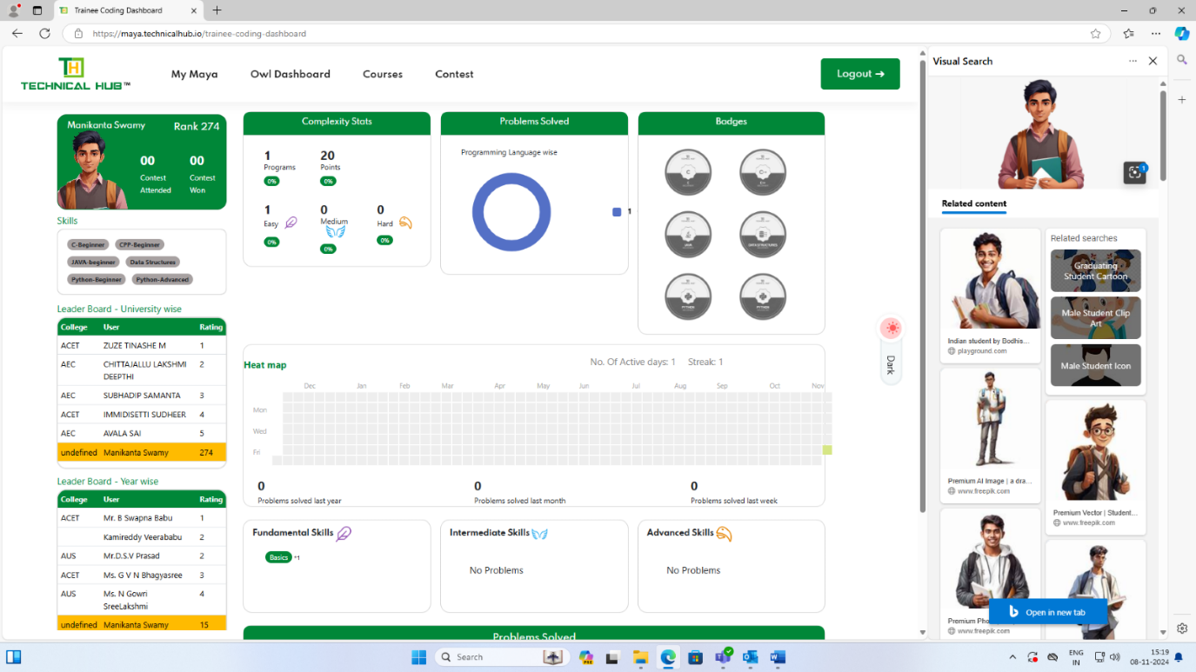

Bug :28
STEP 1: Once user login successfully in My Maya.
STEP 2: Click On ‘Owl Code’.
Actual Result: Bottom left page error message displayed.
Expected Result: Please remove error message.
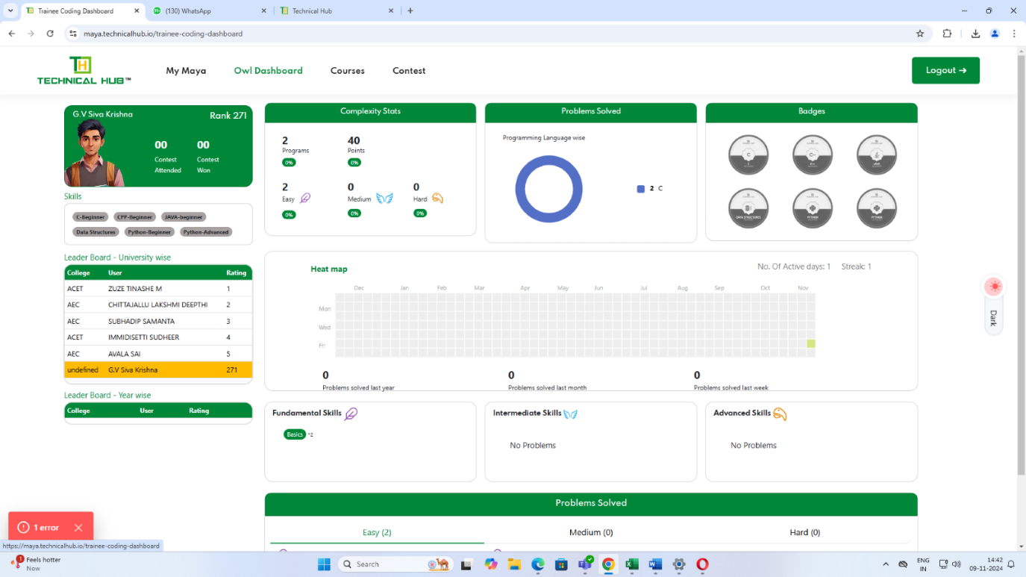

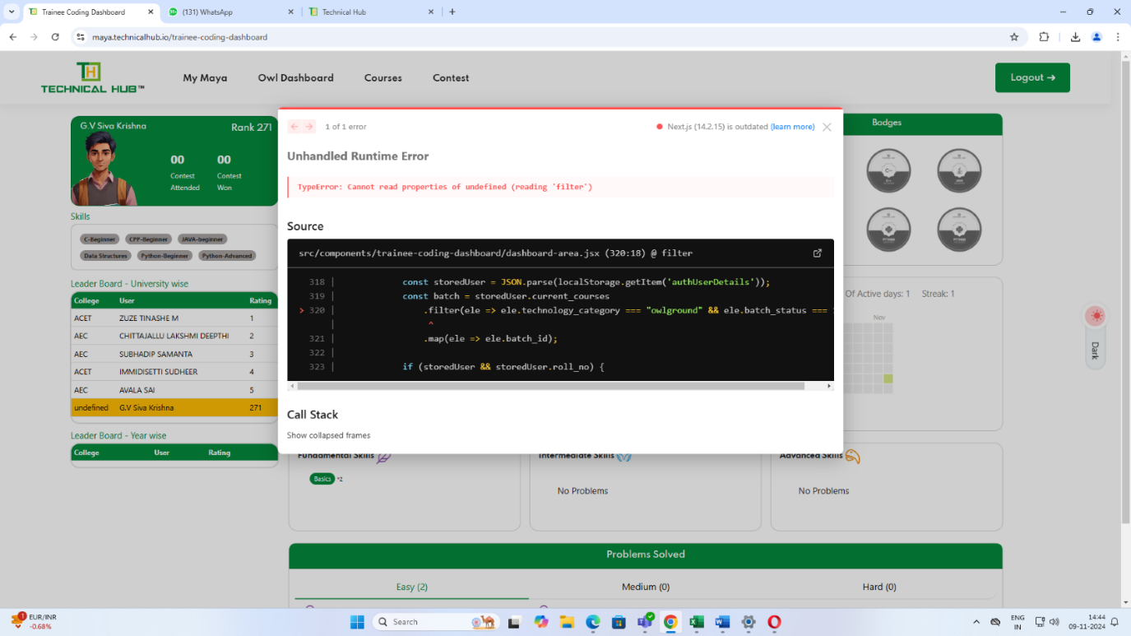
Bug :29
STEP 1: Once user login successfully in My Maya.
STEP 2: Click On ‘Owl Code’.
STEP 3: Whenever trying to scroll the bottom up the page.
Actual Result: It is reflecting top up the page.
Expected Result: It is scrolling the bottom to the page.
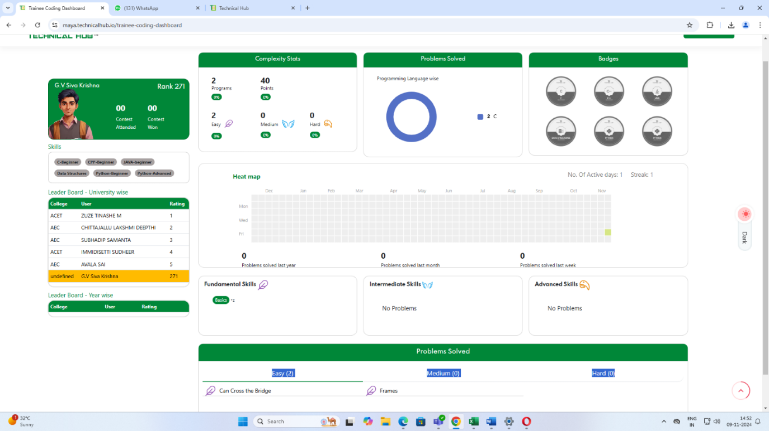
BUG:30
STEP 1: Once user login successfully in My Maya.
STEP 2: Click on ‘Owl code’ link, it is navigated to OWL code dashboard page.
STEP 3: Clicking on ‘Courses’, getting Technologies page is displayed.
Actual Result: Verified that some images are not shown in technologies page.
Expected Result: Verify that all images should display in technologies page.
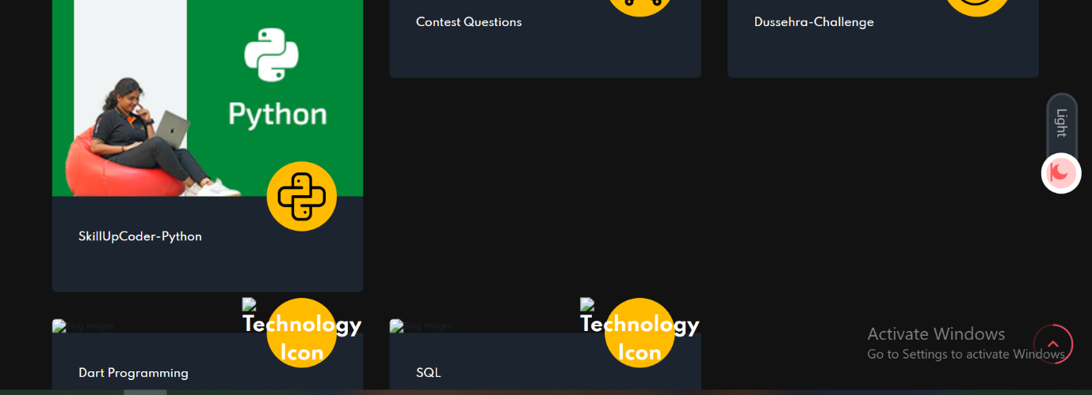

BUG:31
STEP 1: Once user login successfully in My Maya.
STEP 2: Click on ‘Courses’ link, it is navigate to ‘Technology’ page.
STEP 3: Clicking on any course (C, JAVA, Phyton), getting related Language program page is displayed.
STEP 4: Click on dark mode.
Actual Result: Verified that whenever the dark mode is ON, the check boxes are not visible.
Expected Result: Verify that whenever the dark mode is ON, the check boxes should be visible.

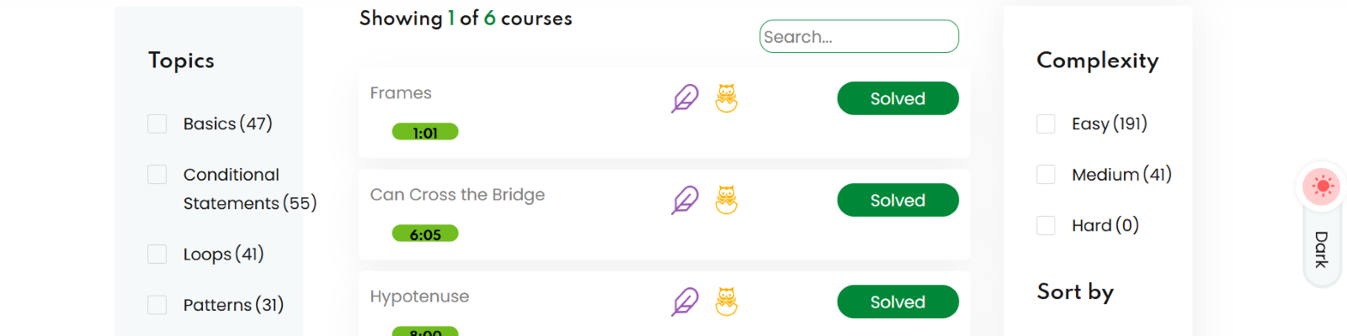
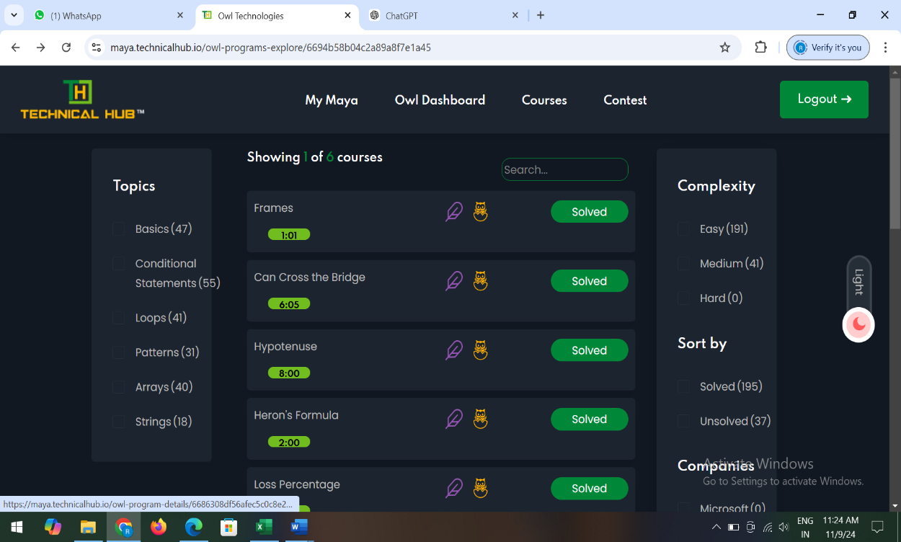

BUG:32
STEP 1: Once user login successfully in My Maya.
STEP 2: Click on ‘Courses’ link, getting Technologies page is displayed.
STEP 3: Clicking on any course (C, JAVA, Phyton), getting Language program page is displayed.
STEP 4: while writing a program in command window, click on Run. If we are getting error Message.
Actual Result: Verified that while write a program in command window, getting error messages in out of line at the bottom of the page.
Expected Result: Verified that while write a program in command window, getting error messages in out of line at the bottom of the page.
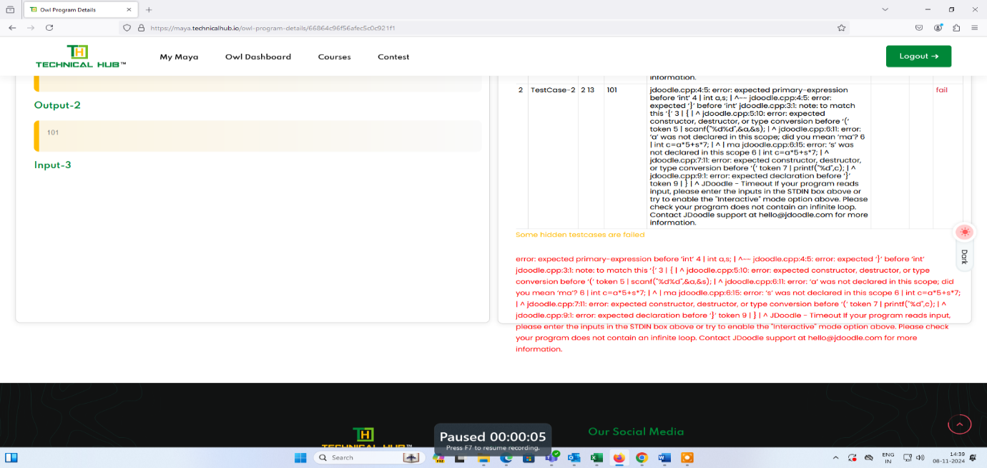

BUG:33
STEP 1: Once user login successfully in My Maya.
STEP 2: Click on ‘Courses’ link, getting Technologies page is displayed.
STEP 3: Clicking on any courses (C, JAVA, Phyton), getting Language program page is displayed.
STEP 4: while writing a program in command window, if we are getting error message, click on dark mode.
Actual Result: Text is not visible in dark mode.
Expected Result: Text is visible in dark mode also.
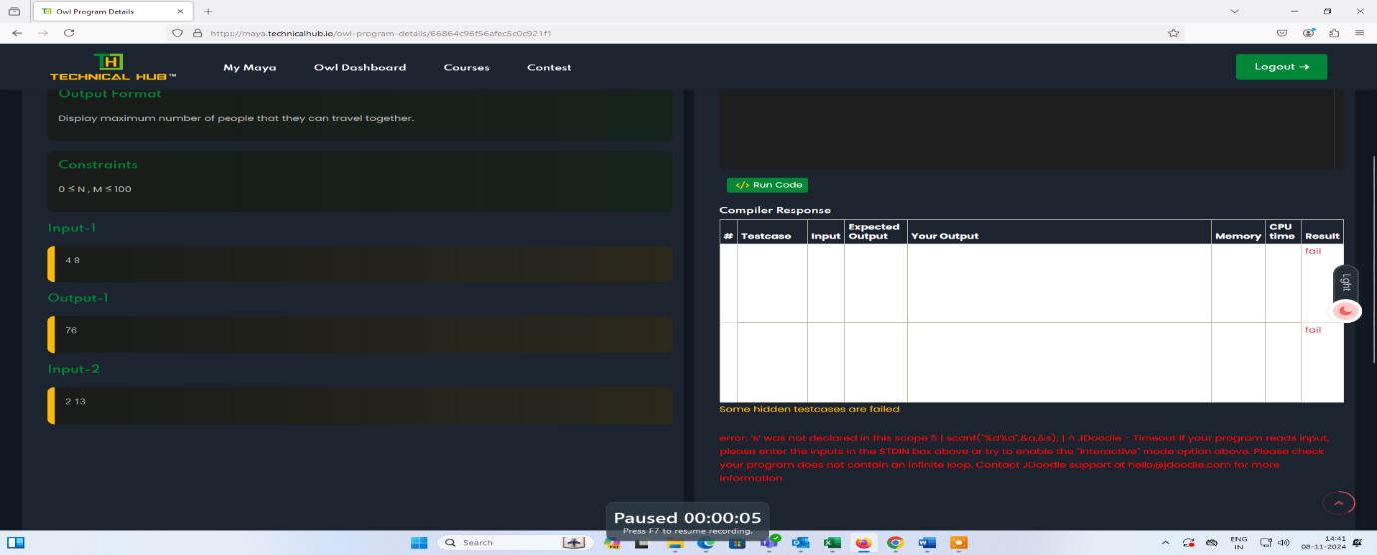

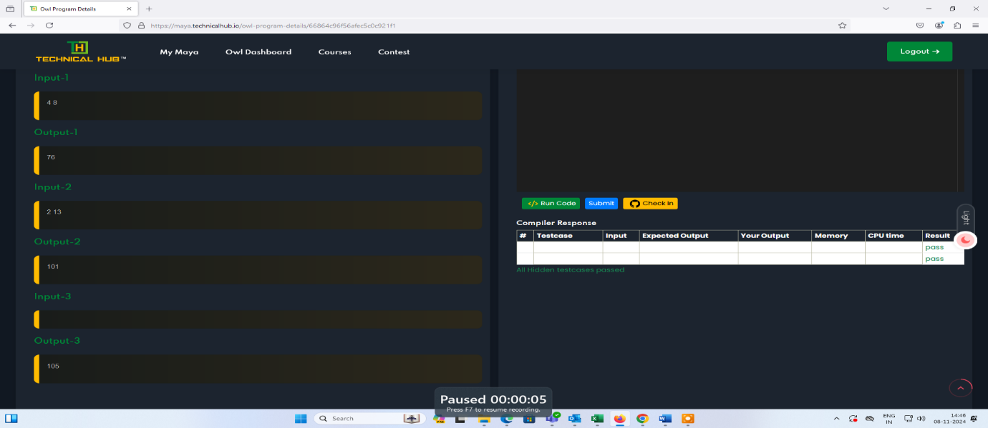
Bug :34
STEP 1: Once user login successfully in My Maya.
STEP 2: Click on ‘Owl Code’
STEP 3: Click On ‘Contest’.
STEP 4: Click on ‘Past Contests’.
STEP 5: while clicking on Past Contest, mouse over to the contest link in light mode.
Actual Result: Verified that while moving the cursor in contest link. Text not visible in light mode. But it is visible in dark mode.
Expected Result: Verify While moving the cursor in contest Link. Text visible in light mode also.
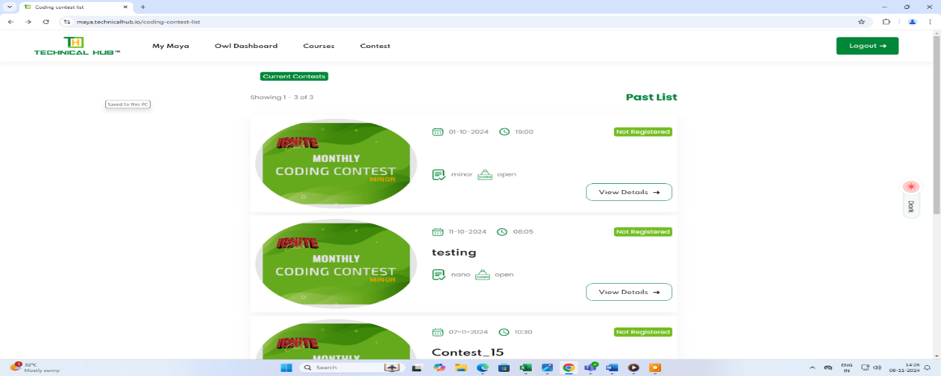
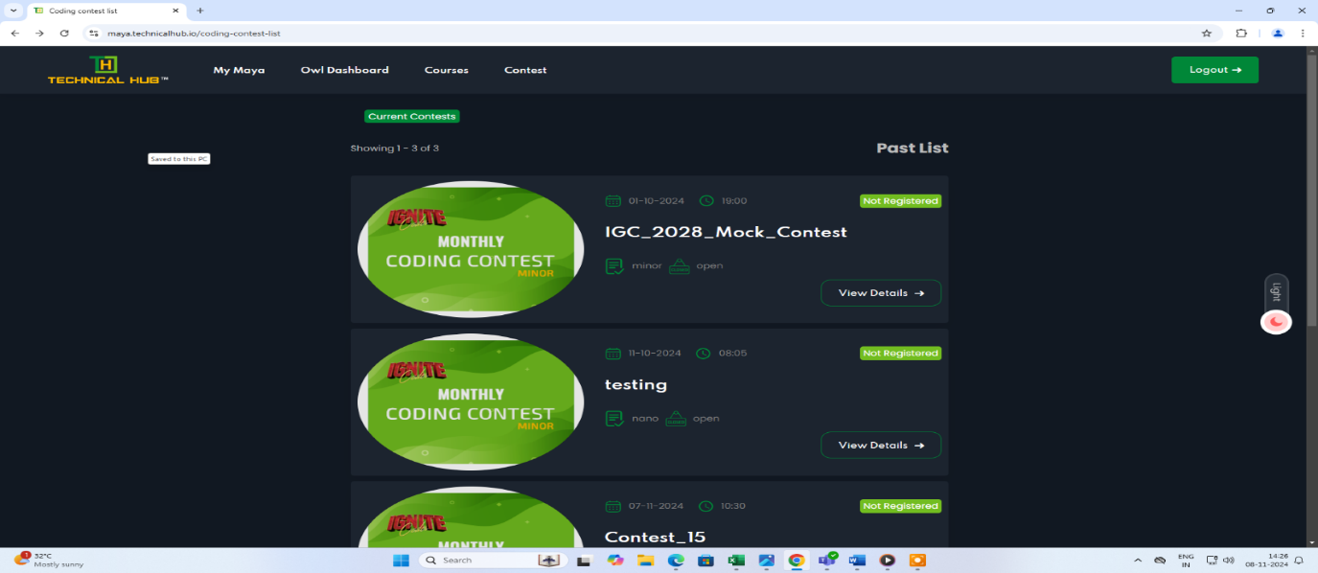

Bug :35
STEP 1: Once user login successfully in My Maya.
STEP 2: Click on ‘Past Contests’.
STEP 3: Click On ‘IGC_2028_Mock _Contest’, click on dark mode.
Actual result: Verified that while Contest info data is visible in light Mode but not visible in dark Mode.
Expected Result: Verify that While contest Info data is Visible in Dark Mode.
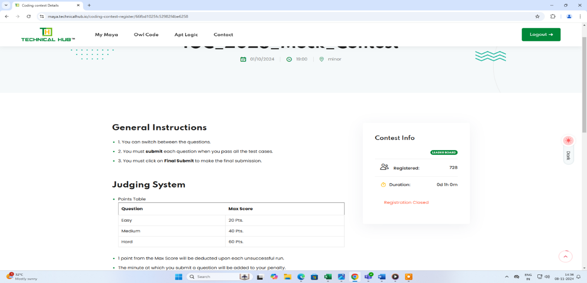
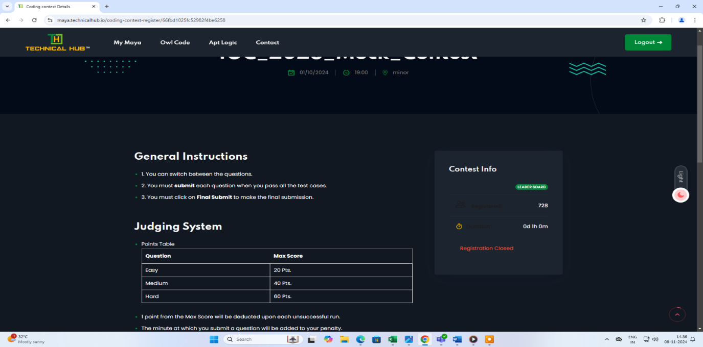

Bug :36
STEP 1: Once user login successfully in My Maya.
STEP 2: Click On ‘Leader Board’, click on dark mode.
Actual result: Verified that while leader board is visible, but the header is not Visible in dark Mode.
Expected Result: Verify while leader board header is visible in dark Mode.
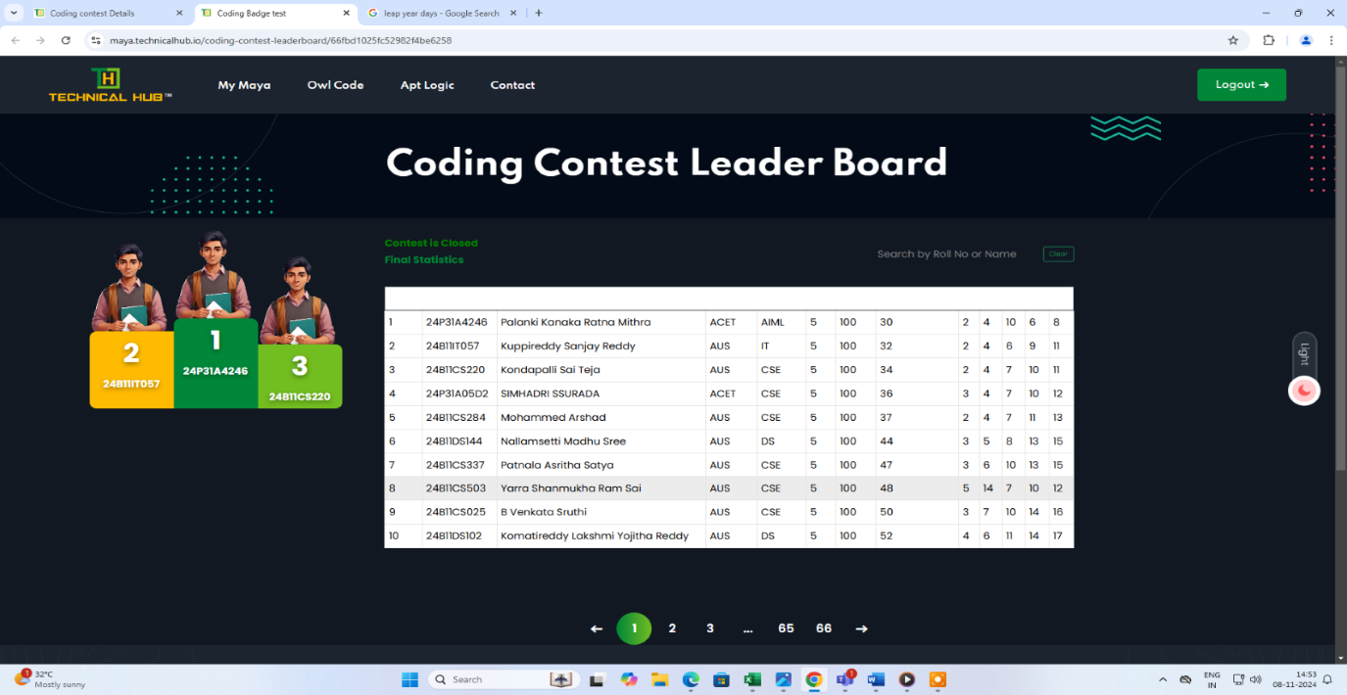
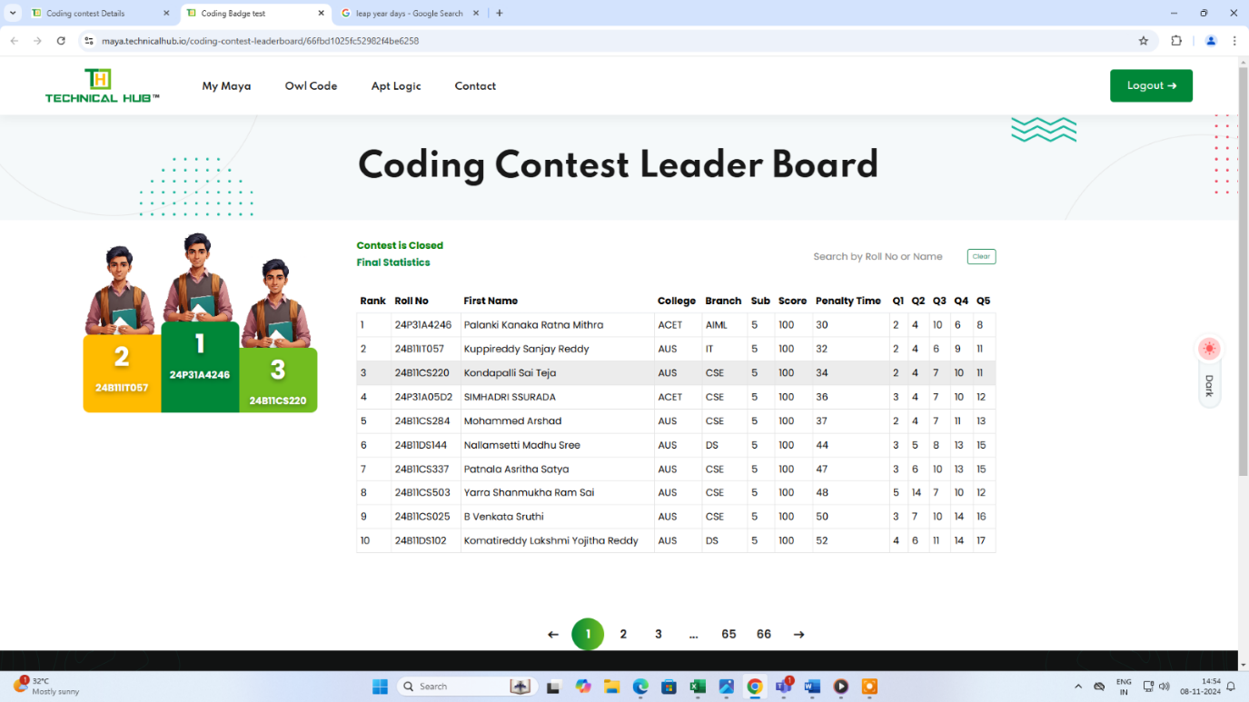

Bug :37
STEP 1: Once user login successfully in My Maya.
STEP 2: Click On ‘Leader Board’, click on any page.
Actual result: Page is visible in few seconds then after it will automatically be redirecting to first page.
Expected Result: Verify while leader board Page is not redirecting first page.
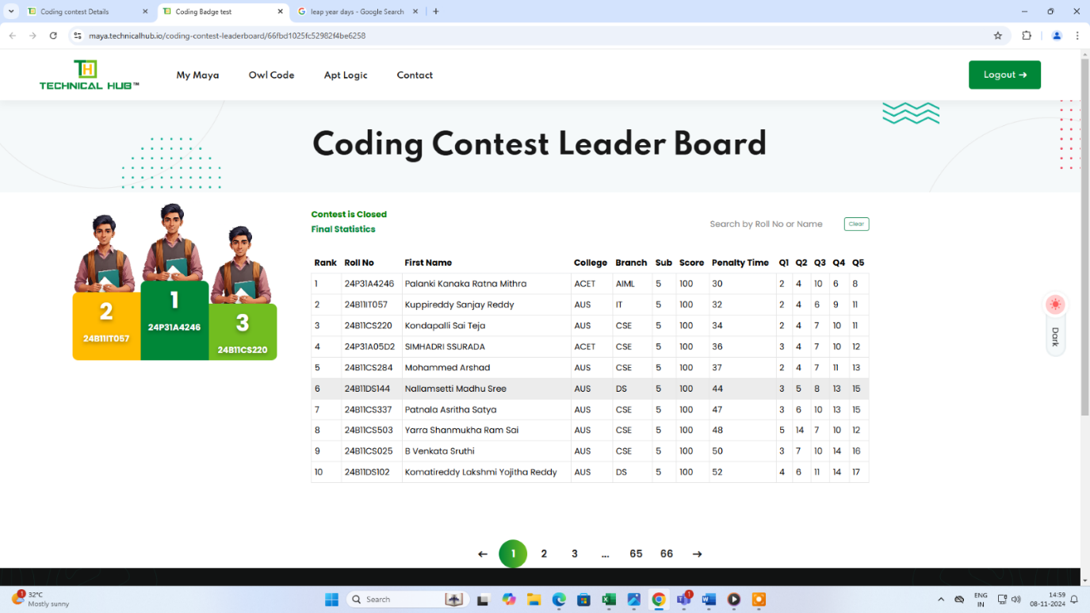
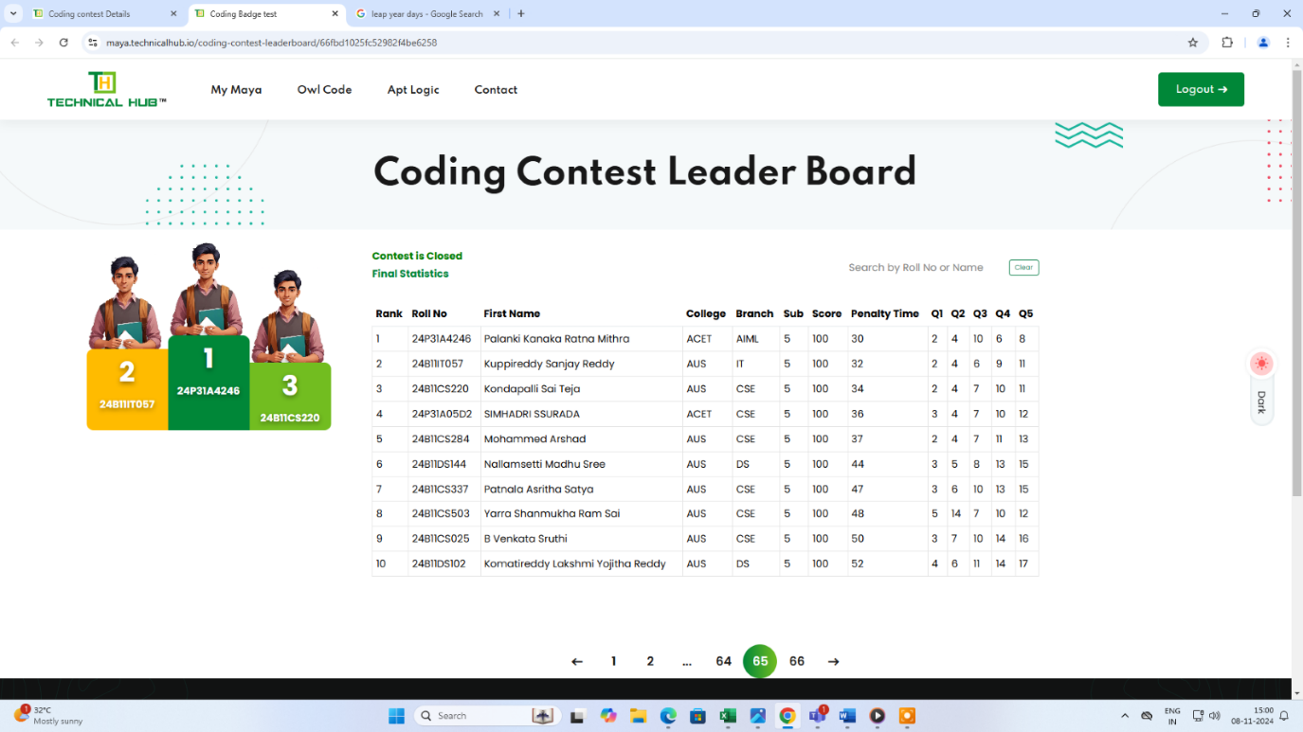

Bug :38
STEP 1: Once user login successfully in My Maya.
STEP 2: Click On ‘Leader Board’.
STEP 3: Enter The roll number/ Student name.
STEP 4: It is visible the student data, then after click on clear.
Actual result: After getting student data, while click on clear, data is not clear in search bar.
Expected Result: After getting student data, while click on clear, data should be clear in search bar.
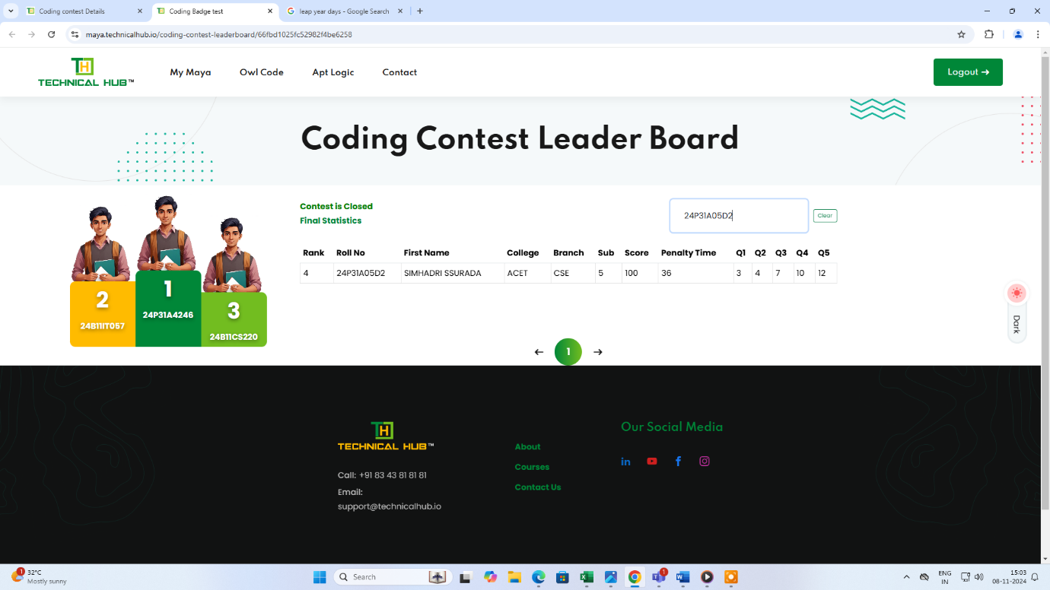
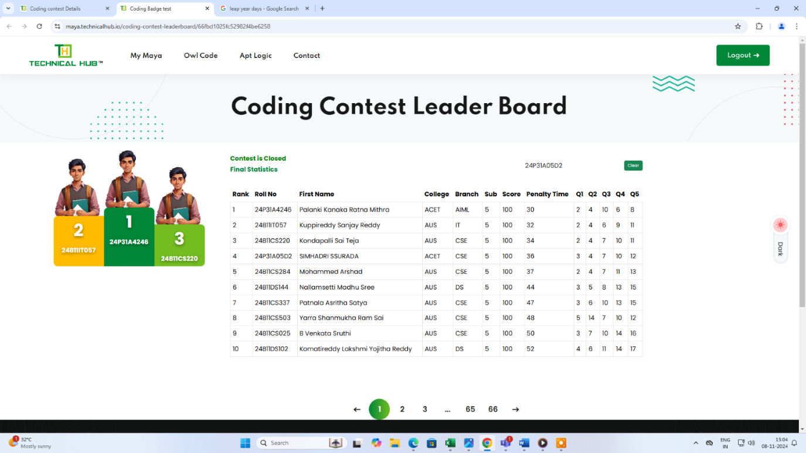

Bug :39
STEP 1: Once user login successfully in My Maya.
STEP 2: Click On ‘IGC_2028_Mock _Contest’.
STEP 3: click on back navigation.
Actual result: It is reflected to past contests page.
Expected Result: whenever click on back navigation it is reflected to current contests page.
